RadAssist Complete Feature Catalogue
AI-Assisted Radiology Reporting Workspace — every delivered feature, from the smallest to the principal ones, with a screenshot of each screen that has one.
This document lists every user-facing and behavioural feature of the delivered system, ordered from the minimal supporting features up to the principal ones. Each entry states what the feature does, where it lives, how it actually works, and what its limits are. Every screenshot is of the current running system, captured on 2026-09-23 at 1440×900; nothing is mocked up, and no screen is shown for a capability the system does not have.

How to read this document

Status vocabulary
Table 1: The four status values used throughout this document.
Source: thesis final report/01_facts/feature_catalogue.md.
Status | Meaning
Implemented | A real route and a real component exist, and the feature works end to end.
Implemented, advisory | It exists and runs, but it deliberately does not block or change anything.
Partial | It exists, but a specific, named part of it does not.
Not implemented | It does not exist in this build. The reason is given in every case.

Ordering
Features are grouped into nine tiers, running from minimal — the foundational features a user touches before doing any clinical work — to main, the retrieval and generation core that is the reason the system exists. A tenth section lists what is deliberately not built.

A note on screenshots
Thirty-three screenshots exist and all thirty-three appear in this document. Several features are genuinely server-side — the admission gate, PHI masking, label voting, the audit logs — and have no screen of their own. Those entries say so explicitly rather than borrowing an unrelated screenshot. Where a feature is visible only as part of a larger screen, the entry names the region of the figure to look at.

Index of all features
Table 2: Every feature in this catalogue, with its tier and status.
Source: This document.
# | Feature | Tier | Status
F-01 | Landing page | 1 Access | Implemented
F-02 | Doctor registration | 1 Access | Implemented
F-03 | Sign in | 1 Access | Implemented
F-04 | Sign out | 1 Access | Implemented
F-05 | Session identity | 1 Access | Implemented
F-06 | Password storage (Argon2id) | 1 Access | Implemented
F-07 | Ownership-based access control | 1 Access | Implemented
F-08 | Read-only view of another doctor’s report | 1 Access | Implemented
F-09 | Bilingual interface and reports (EN / বাংলা) | 2 Shell | Implemented, unevaluated
F-10 | Light and dark themes | 2 Shell | Implemented
F-11 | Navigation rail | 2 Shell | Implemented
F-12 | Settings and profile | 2 Shell | Implemented
F-13 | Workspace defaults | 2 Shell | Implemented
F-14 | Unsaved-work guard | 2 Shell | Implemented
F-15 | Service health strip | 2 Shell | Implemented
F-16 | System statistics | 2 Shell | Implemented
F-17 | Queue / worklist | 3 Patients | Implemented
F-18 | Patients directory | 3 Patients | Implemented
F-19 | Find patient | 3 Patients | Implemented
F-20 | Register patient | 3 Patients | Implemented
F-21 | Patient profile and prior studies | 3 Patients | Implemented
F-22 | Institutional patient model | 3 Patients | Implemented by design
F-23 | New examination guided flow | 4 Intake | Implemented
F-24 | Declared projection (required) | 4 Intake | Implemented
F-25 | Image admission gate (A1–A13) | 4 Intake | Implemented
F-26 | PHI masking | 4 Intake | Implemented
F-27 | PHI reveal slider | 4 Intake | Implemented
F-28 | Modality gate | 4 Intake | Implemented (blocks)
F-29 | Projection band gate | 4 Intake | Implemented (blocks)
F-30 | Upload rejection audit | 4 Intake | Implemented
F-31 | BiomedCLIP image embedding | 5 Retrieval | Implemented
F-32 | k-NN retrieval over the knowledge base | 5 Retrieval | Implemented
F-33 | Label voting and agreement | 5 Retrieval | Implemented
F-34 | Retrieval support signal | 5 Retrieval | Implemented
F-35 | Query image replay | 5 Retrieval | Implemented
F-36 | Clinical questionnaire | 6 Generation | Implemented
F-37 | Clinical notes | 6 Generation | Implemented
F-38 | Report generation (seven fields) | 6 Generation | Implemented
F-39 | Structural validation and content retry | 6 Generation | Implemented (blocks)
F-40 | Semantic validation | 6 Generation | Implemented, advisory
F-41 | Server-authored disclaimer | 6 Generation | Implemented
F-42 | Consistency checking (three checks, four states) | 6 Generation | Partial
F-43 | Report page, summary first | 7 Review | Implemented
F-44 | Full-report disclosure | 7 Review | Implemented
F-45 | Section editing | 7 Review | Implemented
F-46 | Section regeneration | 7 Review | Implemented
F-47 | Word-level diff | 7 Review | Implemented
F-48 | Finalize | 7 Review | Implemented
F-49 | Delete report | 7 Review | Implemented
F-50 | Report edit audit | 7 Review | Partial
F-51 | Evidence tab | 8 Evidence | Implemented
F-52 | Agreement tab | 8 Evidence | Implemented
F-53 | Alternatives tab | 8 Evidence | Implemented
F-54 | No-refetch navigation guarantee | 8 Evidence | Implemented
F-55 | Explainability assistant | 8 Evidence | Implemented
F-56 | Longitudinal comparison | 8 Evidence | Implemented
F-57 | Print / Save as PDF | 9 Output | Implemented (browser)
F-58 | Bengali print | 9 Output | Implemented, verified
F-59–F-68 | Ten capabilities deliberately not built | 10 | Not implemented

Tier 1 Access and Identity
The minimal features. Nothing clinical is reachable until a doctor has an account and a session, and every clinical action is scoped by who they are.

F-01 Landing page
Status: Implemented · Where: Route / (public) · Interface: Web page
The public entry screen. It states what the system does and offers the two routes in: Sign in and Register. It is the only clinical-adjacent screen reachable without a session.
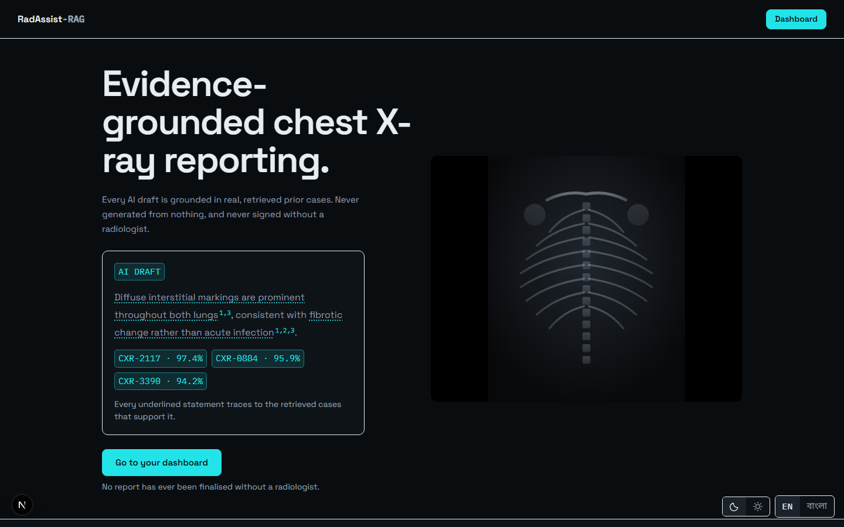
Figure 1: The public landing page — the first screen a new user meets.
Source: 05_screenshots/01-landing-dark.png — captured 2026-09-23 at 1440×900 from the running system.

F-02 Doctor registration
Status: Implemented · Where: Route /register · Interface: POST /auth/register
Creates a doctor account from full name, email, password and an optional BMDC number. On success the account is created and a session cookie is issued.
The BMDC number is recorded exactly as entered and is never verified. This is stated on the form itself — “This system has no access to the BMDC registry and cannot verify it” — rather than left for the user to assume. The number is stored and printed on the report; nothing in the system treats it as a validated credential. See F-59.
Password rules are enforced at the form. There is no email verification, and consequently no password reset (F-64).
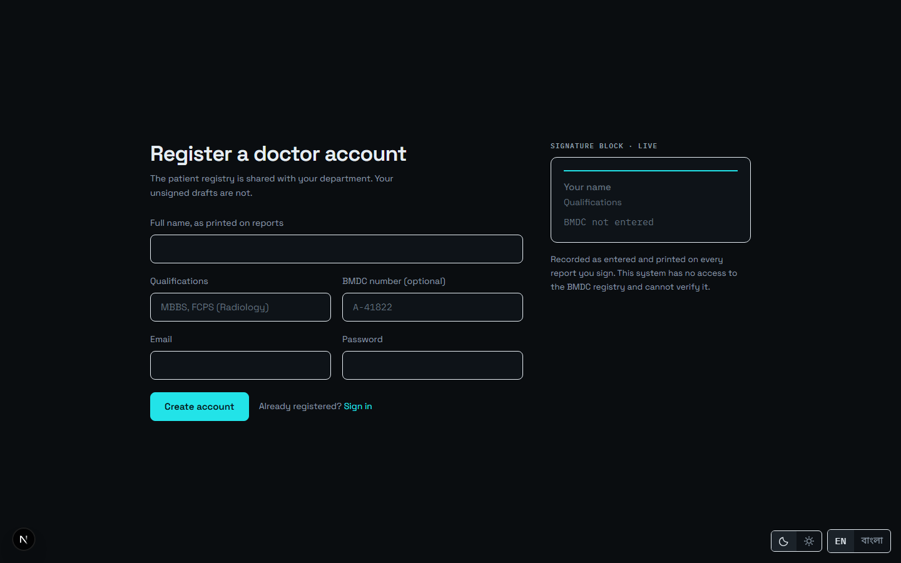
Figure 2: Doctor registration: full name, email, BMDC number and password. The form states that the BMDC number is not verified.
Source: 05_screenshots/02-registration-dark.png — captured 2026-09-23 at 1440×900 from the running system.

F-03 Sign in
Status: Implemented · Where: Route /login · Interface: POST /auth/login
Email and password authentication. On success the server issues a JWT in an httpOnly cookie named radassist_token, and the browser lands on the queue.
The cookie is httpOnly rather than an Authorization header held in JavaScript, so the token is inaccessible to frontend JS, mitigating XSS token theft. It is signed HS256 and expires after 1,440 minutes (24 hours).
Operational note: the application must be served from http://localhost:3000. The cookie is SameSite=Lax, and browsers treat localhost and 127.0.0.1 as different sites — so a session opened on the IP form never sends its cookie back. The backend’s CORS allowlist holds exactly that one origin.
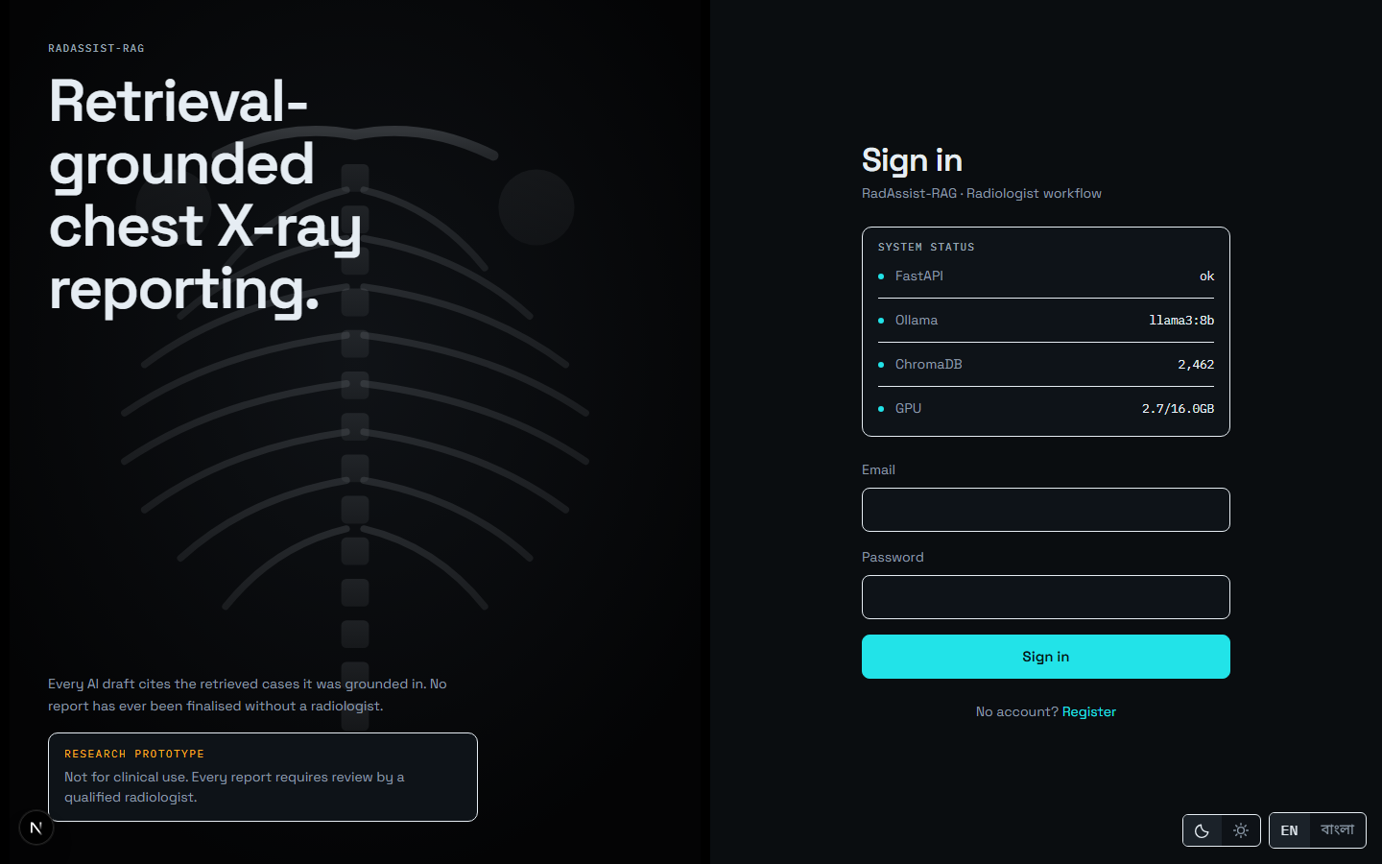
Figure 3: Sign in with email and password.
Source: 05_screenshots/03-login-dark.png — captured 2026-09-23 at 1440×900 from the running system.
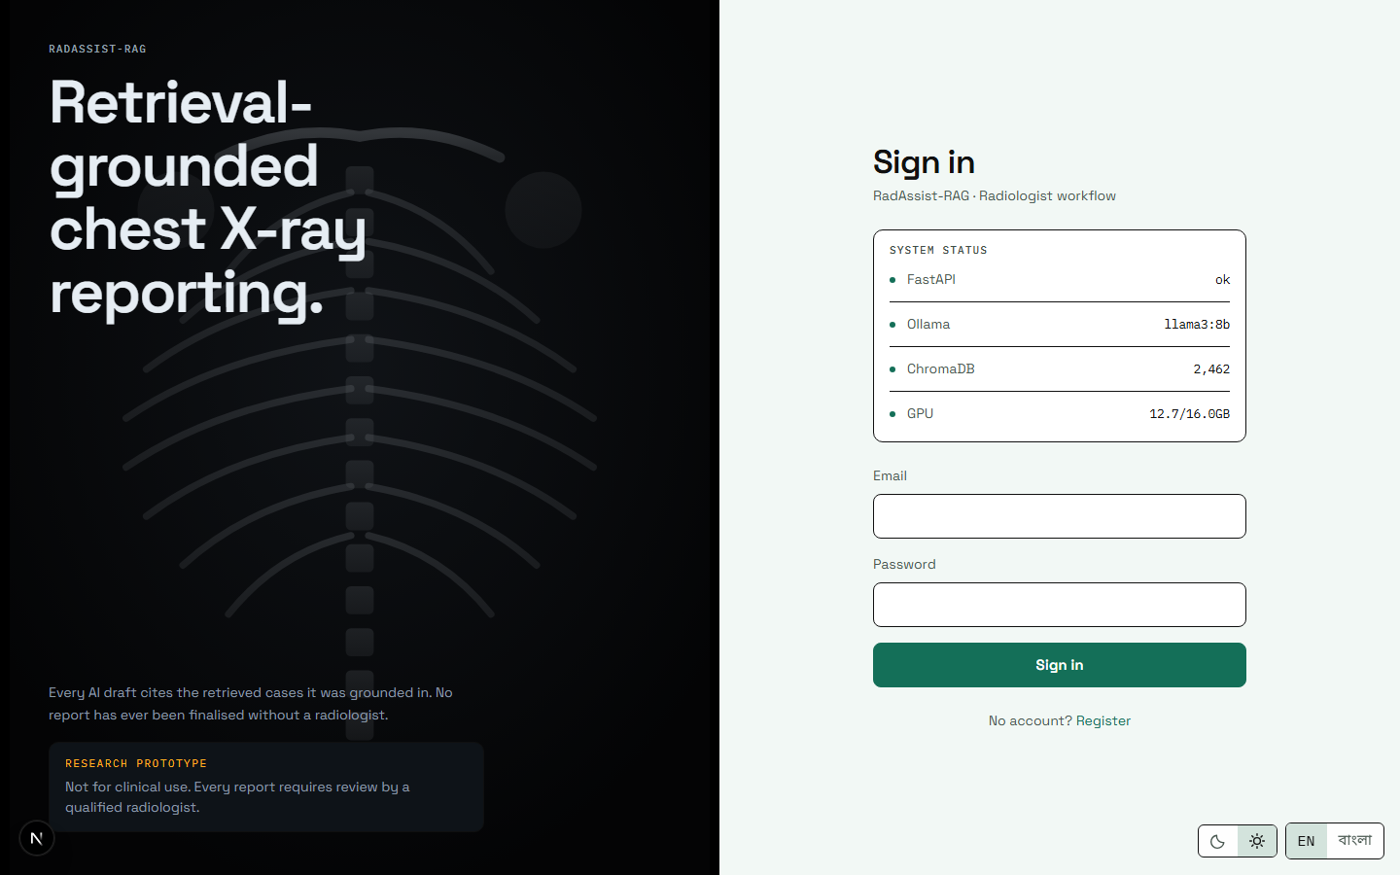
Figure 4: The same screen in the light theme. Both themes are separately derived palettes, not inversions of one another.
Source: 05_screenshots/28-login-light.png — captured 2026-09-23 at 1440×900 from the running system.

F-04 Sign out
Status: Implemented · Where: Navigation rail · Interface: POST /auth/logout
Clears the authentication cookie server-side. No dedicated screenshot — the control lives at the foot of the navigation rail, visible in Figure 7 and every subsequent signed-in screen.

F-05 Session identity
Status: Implemented · Where: Every protected route · Interface: GET /auth/me
Resolves the signed-in doctor on every protected request. The real doctor record is fetched, not merely the token claim — so a validly signed token belonging to a deleted account is rejected with 401 rather than silently trusted.
The response is self-scoped: it carries the BMDC number and the five workspace preferences. A separate, deliberately narrower shape is used when one doctor reads another’s public details, and those private fields must never be added to it.

F-06 Password storage
Status: Implemented · Where: Backend only · Interface: Argon2id via argon2-cffi
Passwords are stored as Argon2id hashes. The salt lives inside the encoded hash string, which is why the doctors table has no salt column. No screenshot — this feature is invisible by design.

F-07 Ownership-based access control
Status: Implemented · Where: All write paths · Interface: Enforced in ReportEditService
Access control is ownership only; there are no roles. A doctor may modify only the work they created. The rule is a single four-line function, and edit, finalize, delete and regenerate all call it — so a non-owner is refused deletion exactly as they are refused an edit, rather than each path re-implementing its own check.
Two properties are worth stating. A report whose owner is NULL fails closed: it is owned by nobody and editable by nobody. And a finalized report is refused with HTTP 409 regardless of ownership — even its author cannot edit it, because a signed report is an audit record.
No screenshot: the feature is visible only as the absence of edit controls, which is F-08.

F-08 Read-only view of another doctor’s report
Status: Implemented · Where: Any report route · Interface: Reading is deliberately not ownership-gated
Any authenticated doctor may read any report. This is deliberate rather than an oversight: in a department, a colleague must be able to look at a report. What changes for a non-owner is the interface — an owner chip names who owns it and every edit control is hidden. Every write attempt is refused with HTTP 403 at the server, so hiding the controls is a courtesy, not the security boundary.

Tier 2 Interface Shell
Cross-cutting features present on every screen.

F-09 Bilingual interface and reports (EN / বাংলা)
Status: Implemented, and entirely unevaluated · Where: Toggle on every screen · Interface: Language flows to POST /generate-report
A global toggle switches the whole interface between English and Bengali, and new reports are drafted in the selected language. The two dictionaries are held at exact key parity — 412 keys in both — by a script in the build gate, which exists because a missing key does not raise an error: it silently falls back, which is precisely the failure that would go unnoticed.
Reports are generated directly in Bengali, not translated from English. There is no translation pass anywhere in the system; the prompt builder deliberately omits the translation method its interface declares, because there is nothing for it to do.
The limitation is significant and must accompany any description of this feature: no Bengali output has ever been evaluated. Every evaluation harness in the project generates English only, and all three consistency checks are English-only by construction. A Bengali report therefore correctly reports that its checks were not run, rather than displaying a pass it has not earned.
A known gap is visible in the figure below: the validation warning text remains in English on an otherwise fully Bengali screen, because those strings are composed by the backend with string interpolation and no translation path reaches them.
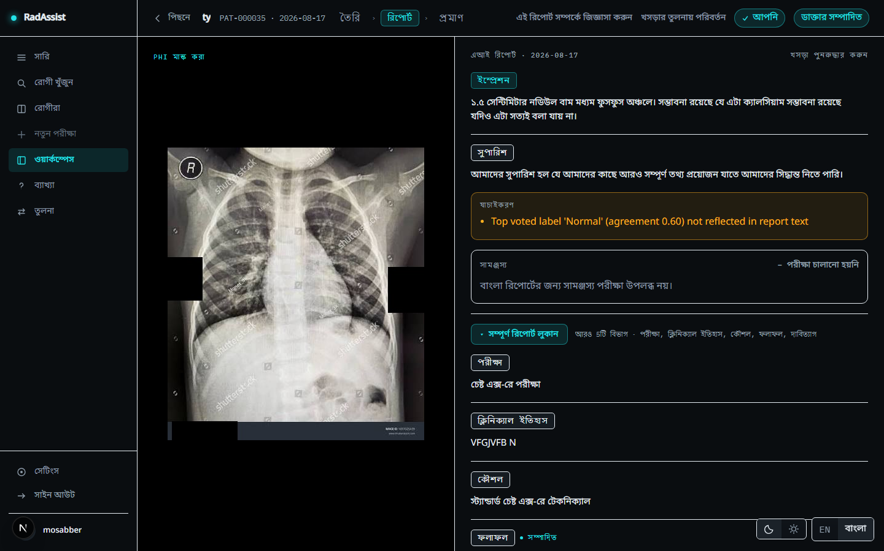
Figure 5: A Bengali report. Interface and report body are both Bengali; the consistency block reads “checks not run” with its reason in Bengali. Note the validation warning, still in English — a known gap.
Source: 05_screenshots/27-report-bengali-dark.png — captured 2026-09-23 at 1440×900 from the running system.

F-10 Light and dark themes
Status: Implemented · Where: Toggle on every screen · Interface: Server-read cookie, no flash on navigation
Dark is the product’s native theme; light is a separately derived palette, not an inversion. Every colour pair was measured for contrast over its real composited backdrop in both themes, and the lowest value against a 4.5:1 target is 4.65:1. Measuring found a genuine defect during development — a status token at 3.83:1, below AA for text a clinician acts on — which was then corrected.
The theme is read from a cookie by the server layout before first paint, so navigation never flashes the wrong palette. One element is theme-invariant: the film panel stays black in both themes, because a radiograph is read against black and that is a clinical condition rather than a stylistic choice.
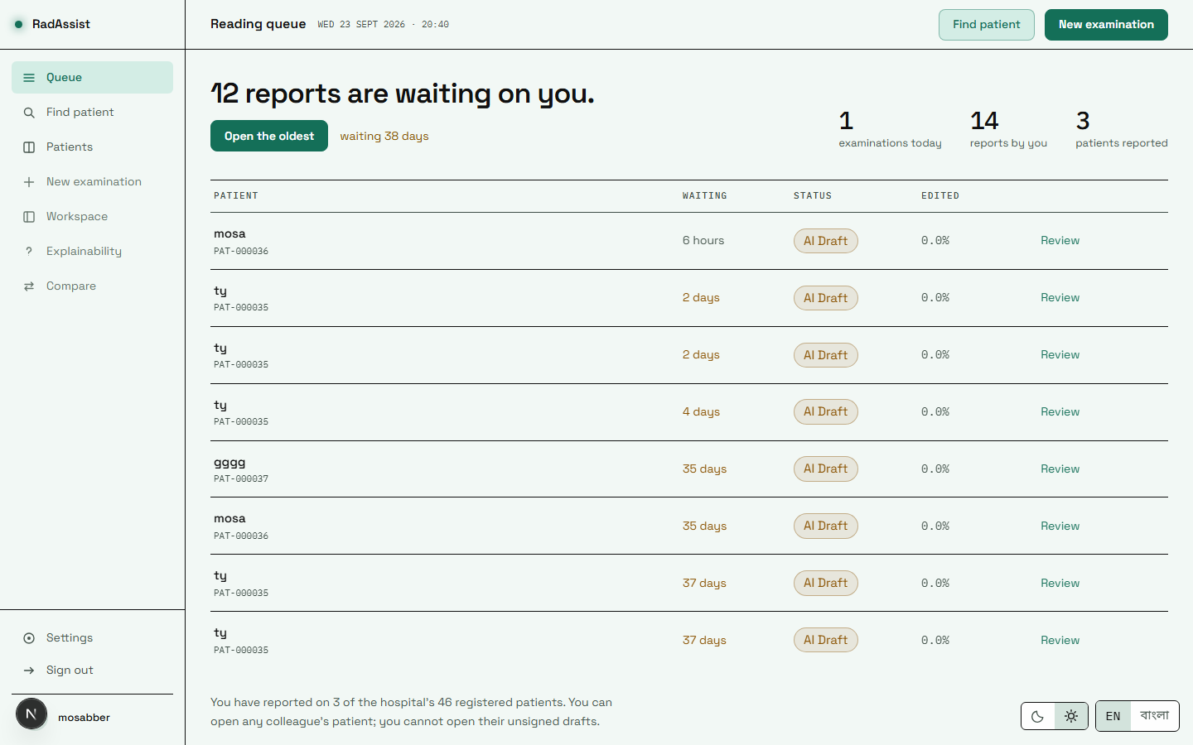
Figure 6: The queue in the light theme.
Source: 05_screenshots/29-queue-light.png — captured 2026-09-23 at 1440×900 from the running system.
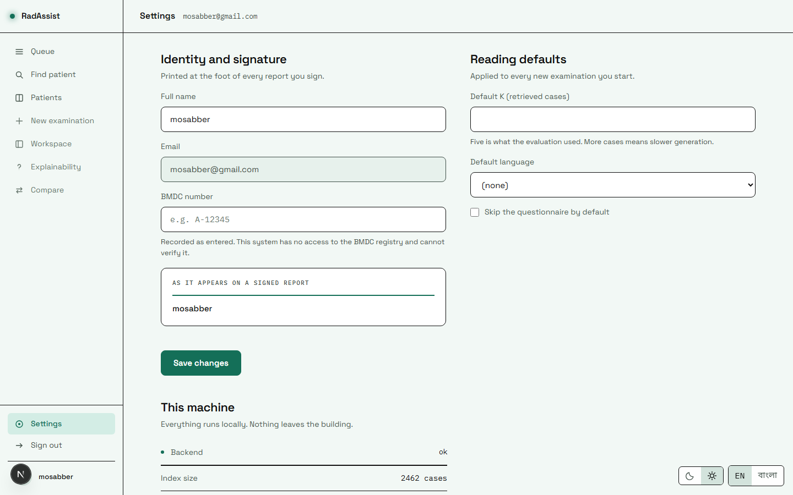
Figure 7: Settings in the light theme.
Source: 05_screenshots/33-settings-light.png — captured 2026-09-23 at 1440×900 from the running system.
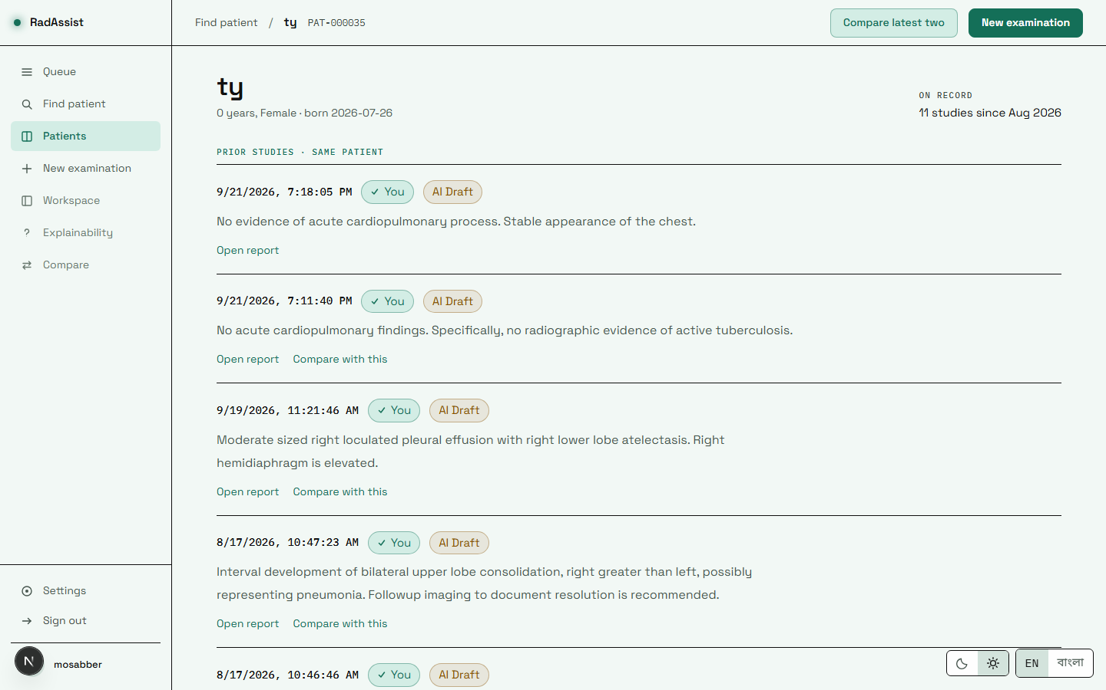
Figure 8: The patient profile in the light theme.
Source: 05_screenshots/30-patient-profile-light.png — captured 2026-09-23 at 1440×900 from the running system.

F-11 Navigation rail
Status: Implemented · Where: Every signed-in screen · Interface: Client-side routing
The persistent left rail carries Queue, Find patient, Patients, New examination, Workspace, Explainability and Compare, plus Settings and Sign out at the foot. Every item routes. An earlier build rendered four of the seven as inert elements whenever no patient or report identifier was in the URL — on the two most-used screens — styled almost identically to live items. Each now routes either to its destination, or to the screen where the missing thing is chosen, dimmed a step with a tooltip naming what it needs.
The rail is visible on the left of every signed-in figure in this document.

F-12 Settings and profile
Status: Implemented · Where: Route /settings · Interface: PATCH /auth/me
*Settings is the profile screen.* There is no separate /profile route in this build; the rail’s avatar links here. It holds the doctor’s full name and BMDC number alongside the workspace defaults of F-13.
The update endpoint treats an omitted field as different from a null one, so a partial update changes only what it names.
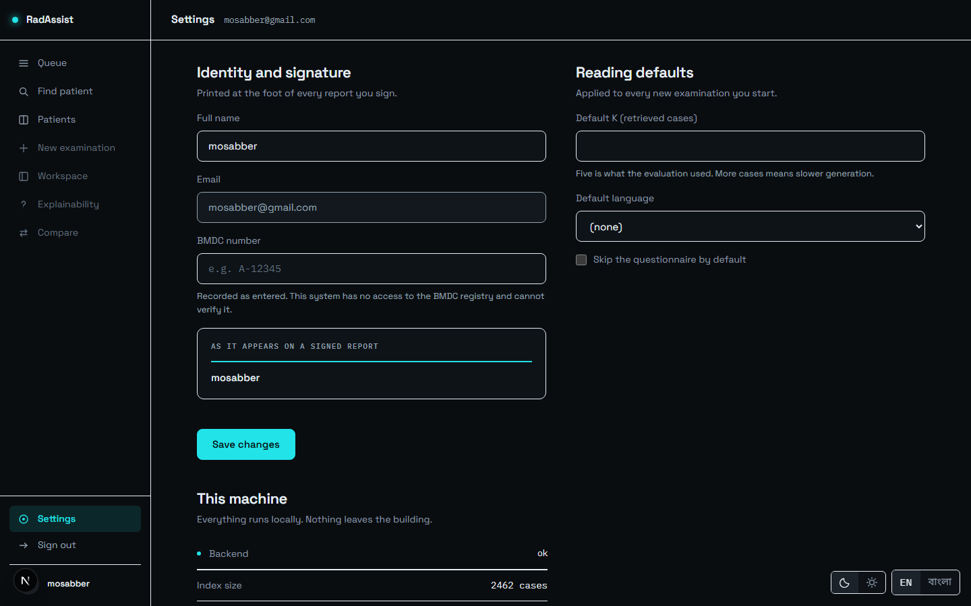
Figure 9: Settings: profile fields and workspace defaults, on one screen.
Source: 05_screenshots/26-settings-profile-dark.png — captured 2026-09-23 at 1440×900 from the running system.

F-13 Workspace defaults
Status: Implemented · Where: Route /settings · Interface: Five columns on the doctor record
Three defaults are honoured throughout the application: how many neighbour cases to retrieve (k), the default language, and whether to skip the questionnaire. They are read once per navigation and consumed by the rail, the upload flow and the settings screen alike.
This feature has a history worth recording, because it is a caution rather than an achievement. An external tester reported that setting k to 3 left the interface still showing 5. Tracing it revealed that every preference the settings screen saved was write-only — five columns persisted to the database and read by nothing, anywhere. The screen saved successfully, showed a success state, and changed nothing. The k value in particular was three unrelated literals: one in the upload flow, one defaulted in the API client, and one rendered in the header.
Three preferences were wired up properly. Two were removed from the interface rather than implemented, because the behaviour they promised did not exist — the rail is deliberately non-collapsible and PDF export does not exist — and a control whose choice cannot be honoured is the same defect as the one reported, not a smaller one.

F-14 Unsaved-work guard
Status: Implemented · Where: Workspace routes · Interface: Browser guard plus in-app guarded navigation
Leaving the workspace with an unsaved edit in progress prompts first. The guard covers the browser’s own navigation and every in-app link, including the step bar — which was specifically brought under the same guard rather than being left as the one exit that could discard work silently. No dedicated screenshot: it is a dialog raised only by a specific action.

F-15 Service health strip
Status: Implemented · Where: Dashboard · Interface: GET /health (the only public route)
Performs real reachability checks against four components — the API itself, Ollama, the vector store and the GPU — rather than reporting a static value. A healthy system reports all four reachable; the vector-store check returns the live document count, which should read 2,462.
The GPU check reports degraded rather than failing the request when no CUDA device is available, because the system runs correctly, if more slowly, without one.

F-16 System statistics
Status: Implemented · Where: Dashboard · Interface: GET /system/stats
Reports the masked and original image counts, the index size read from the vector store itself rather than from configuration, the embedding model and version, the collection name, and the evidence mode. Reading the index size from the store means the figure cannot drift from reality.

Tier 3 Patient Records

F-17 Queue / worklist
Status: Implemented · Where: Route /dashboard · Interface: GET /dashboard/stats
The screen a successful sign-in lands on. It lists every report this doctor owns, newest first, each with its patient, date and a status chip — AI Draft, Doctor edited or Final. The chip is the report’s position in the authorship workflow, not a quality judgement. Clicking any row reopens that report.
The counts above the list are built to agree with the list by construction: the examinations count joins to reports rather than to upload sessions. An earlier build counted sessions, so an upload abandoned before generation was counted in the tile while appearing nowhere in the list beneath it — and since nothing in the interface renders a report-less session, that row could not be reached at all. An abandoned upload is not an examination performed.
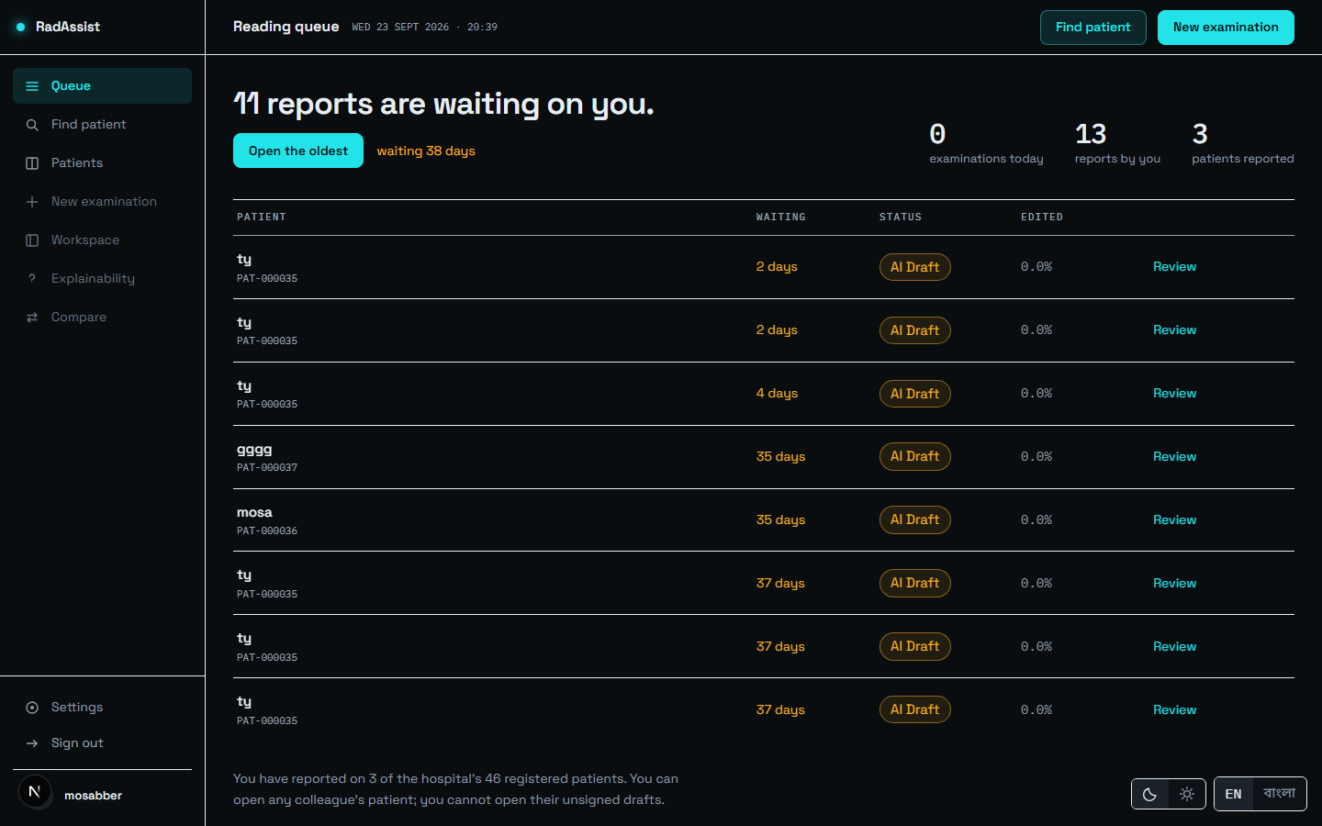
Figure 10: The queue: every report this doctor owns, with patient, date and status chip.
Source: 05_screenshots/04-queue-dark.png — captured 2026-09-23 at 1440×900 from the running system.

F-18 Patients directory
Status: Implemented · Where: Route /patients · Interface: GET /patients
Every patient in the system, in registration order. Distinct from F-19 in intent: this is for browsing when the patient code is not to hand.
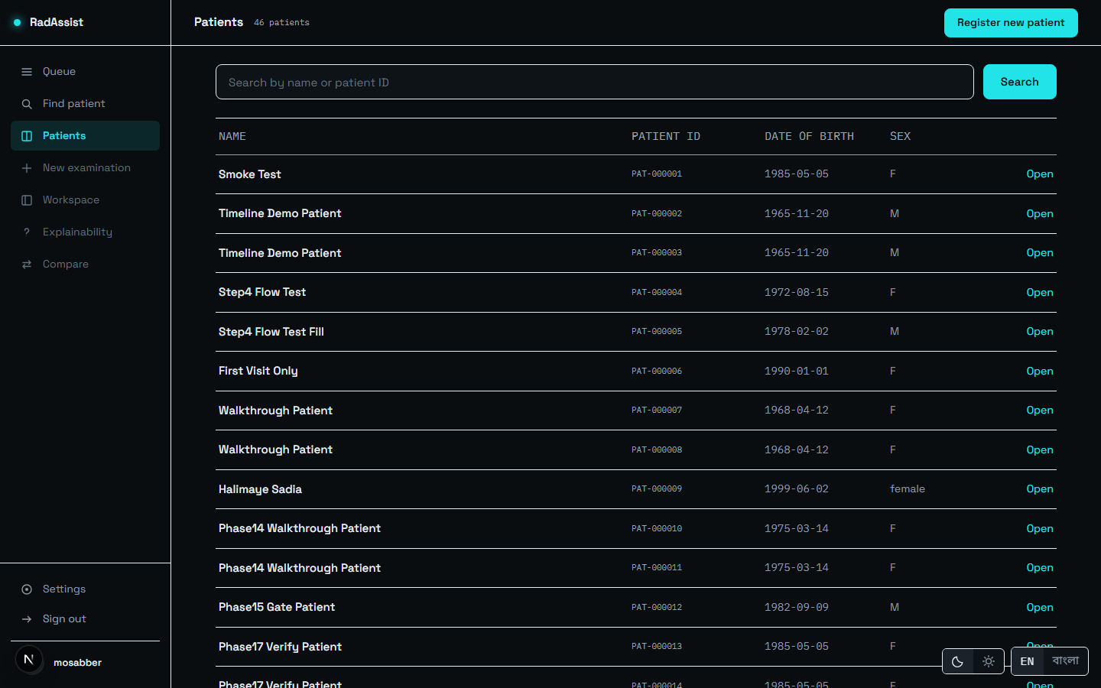
Figure 11: The patients directory — all patients, in registration order.
Source: 05_screenshots/06-patients-dark.png — captured 2026-09-23 at 1440×900 from the running system.

F-19 Find patient
Status: Implemented · Where: Route /patients/search · Interface: GET /patients/search
Search by name or patient code. This is the normal entry point to an examination: find the patient, then start.
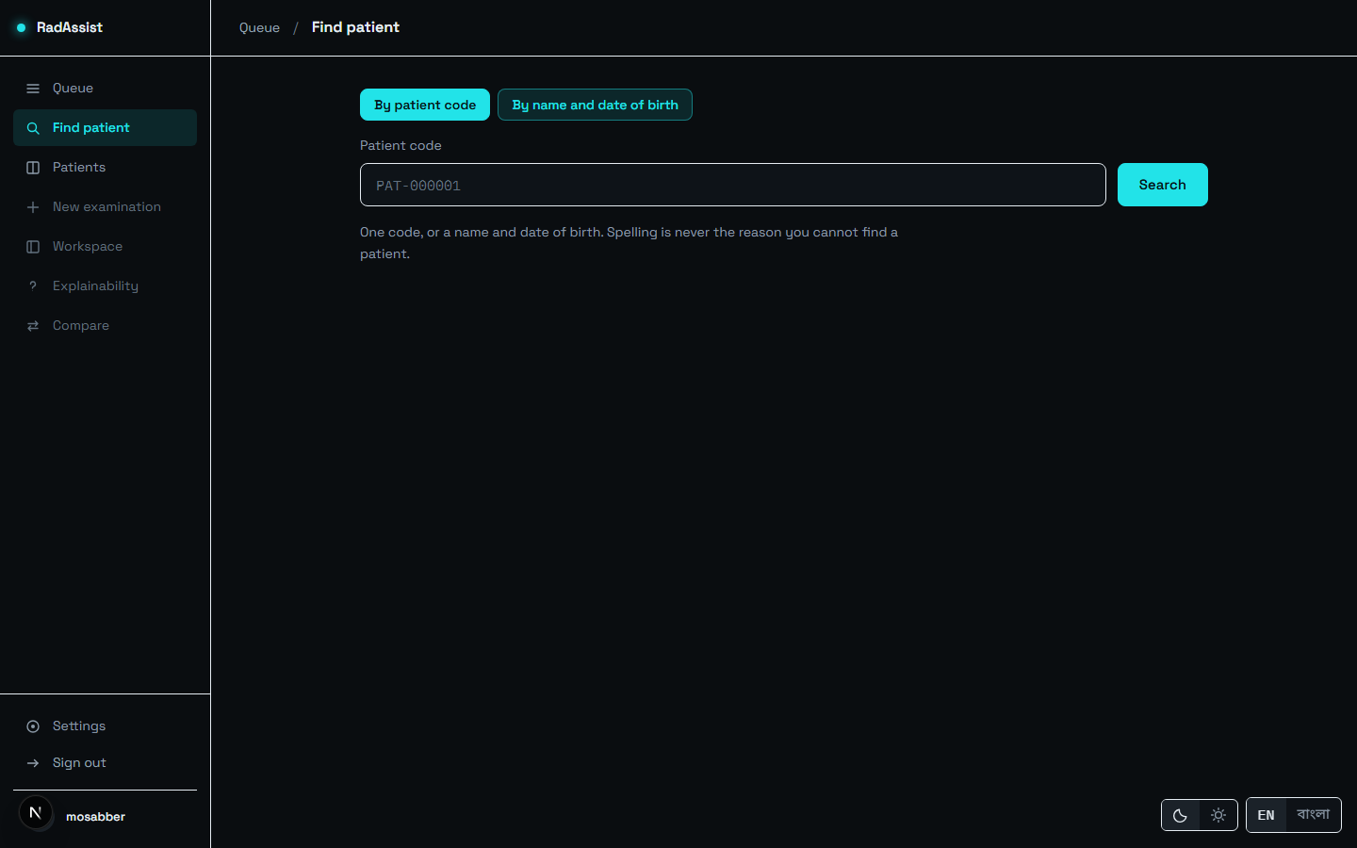
Figure 12: Find a patient by code or name before starting an examination.
Source: 05_screenshots/05-find-patient-dark.png — captured 2026-09-23 at 1440×900 from the running system.

F-20 Register patient
Status: Implemented · Where: Route /patients/new · Interface: POST /patients
Creates a patient from name, date of birth and gender. The system assigns the patient code; it is not typed in, so it cannot collide or be mistyped.
Date of birth is bounded on both sides — in the input control and again in the backend, as a shared validator. An earlier build accepted a six-digit year from the date control, which reached the date parser and raised an unhandled server error rather than a field message. The same validator is called directly by the search endpoint, because a query parameter cannot carry the automatic validation a request body gets, and that path had the identical unhandled parse.
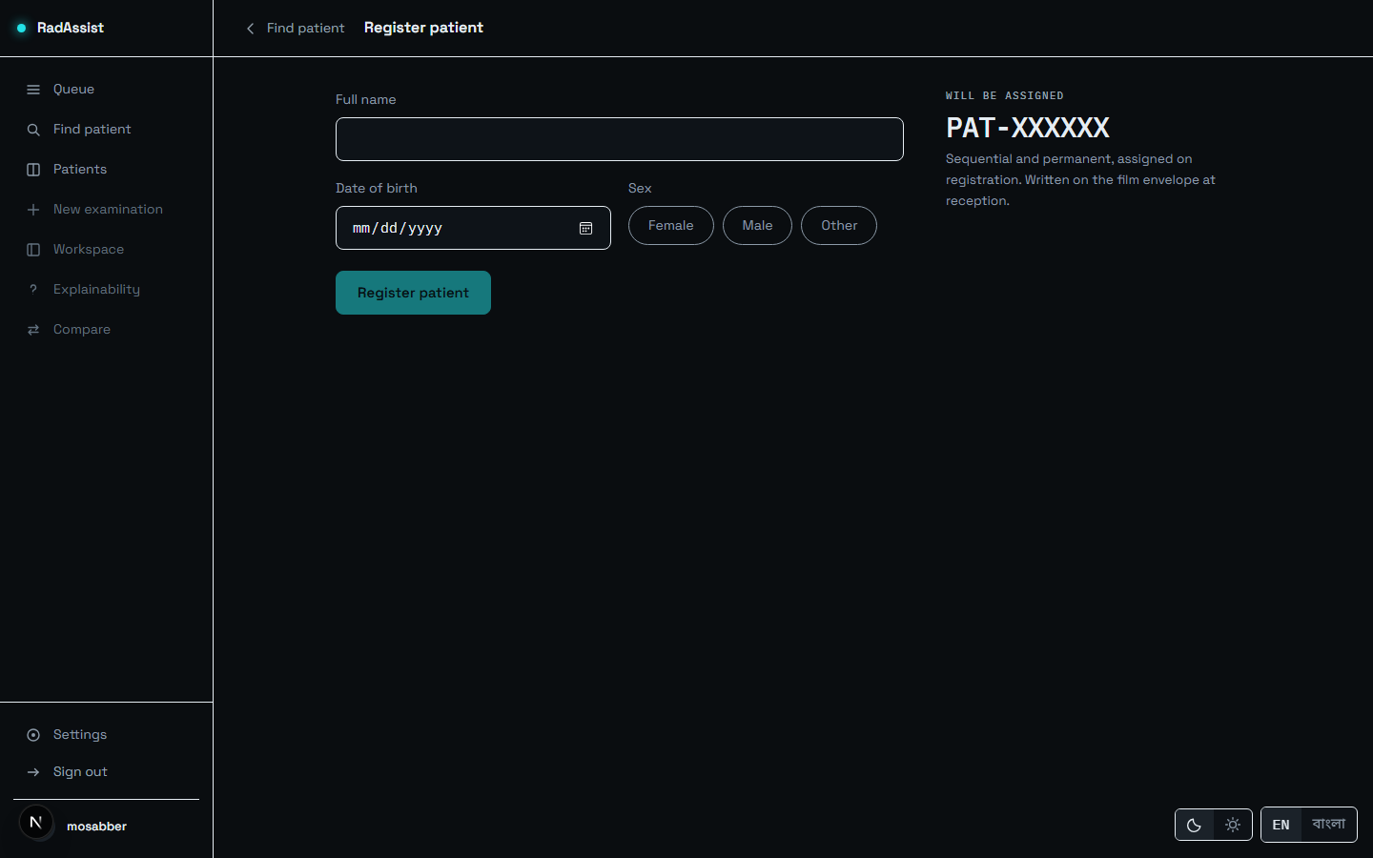
Figure 13: Registering a new patient. The system assigns the patient code.
Source: 05_screenshots/07-register-patient-dark.png — captured 2026-09-23 at 1440×900 from the running system.

F-21 Patient profile and prior studies
Status: Implemented · Where: Route /patients/{id} · Interface: GET /patients/{id}, GET /patients/{id}/history
The patient hub: demographics together with every prior study in chronological order. This list is what makes longitudinal comparison (F-56) possible, and it exposes “compare with this report” on every past visit rather than only the most recent — the comparison endpoint has always accepted an arbitrary prior report, and an earlier interface draft exposed none of that flexibility.
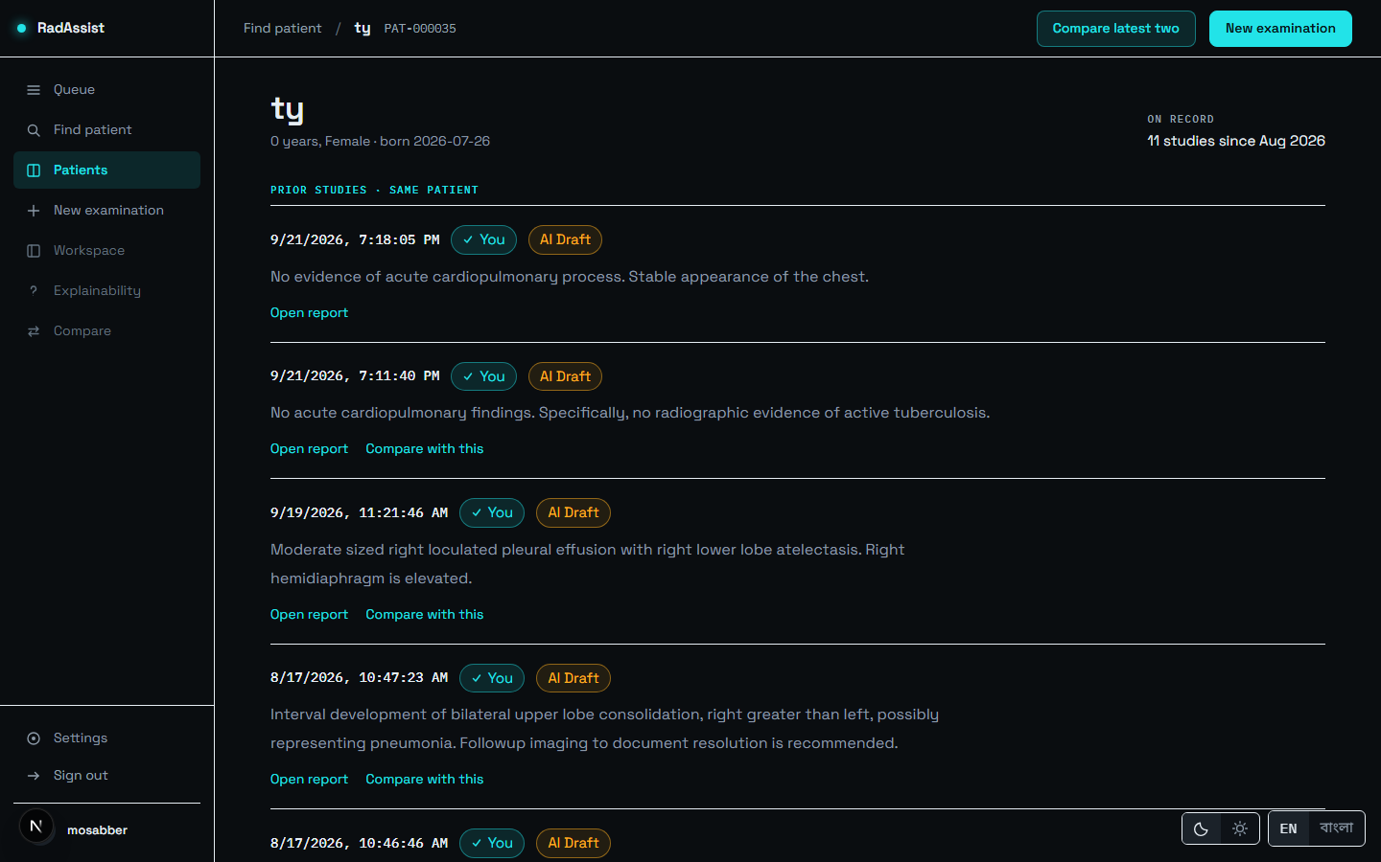
Figure 14: The patient profile: demographics and every prior study, in chronological order.
Source: 05_screenshots/08-patient-profile-dark.png — captured 2026-09-23 at 1440×900 from the running system.

F-22 Institutional patient model
Status: Implemented by design · Where: Data model · Interface: No doctor_id on the patients table
Patients are institutional, not owned. There is no owning doctor on a patient record, so any authenticated doctor can find and open any patient. Ownership attaches to the work — sessions, reports, comparisons and explanations — not to the person, which matches how a department actually operates: a patient is not the property of whichever doctor happened to register them.

Tier 4 Examination Intake and Safety Gates
Everything between choosing a file and having a vector. Four of these features can refuse an upload, and each refusal is a distinct, separately coded outcome rather than a generic error.

F-23 New examination guided flow
Status: Implemented · Where: Route /patients/{id}/upload · Interface: Step 1 of Generate → Report → Evidence
One guided flow rather than a sequence of separate screens: upload → retrieve → questionnaire → generate, with a four-step progress display carrying live per-step timings. The design exists because the pipeline takes seconds rather than milliseconds, and a generic spinner over a multi-second wait reads as a hung application.
The page does not navigate away on its own when generation completes. It offers View result, so the per-step timings stay on screen rather than appearing for a single frame. On a return visit it offers the patient’s most recent report.
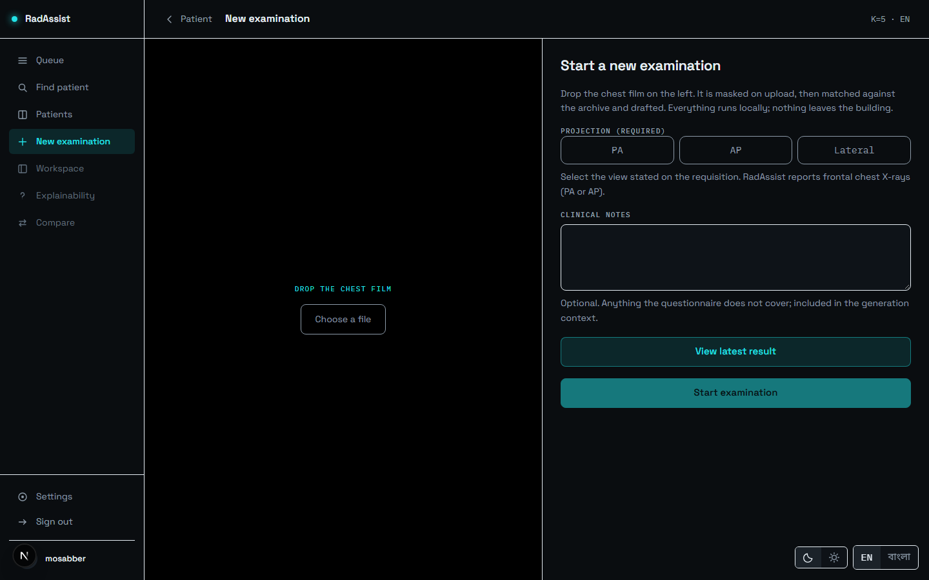
Figure 15: New examination: the film drop target before an image is chosen.
Source: 05_screenshots/09-new-examination-dark.png — captured 2026-09-23 at 1440×900 from the running system.
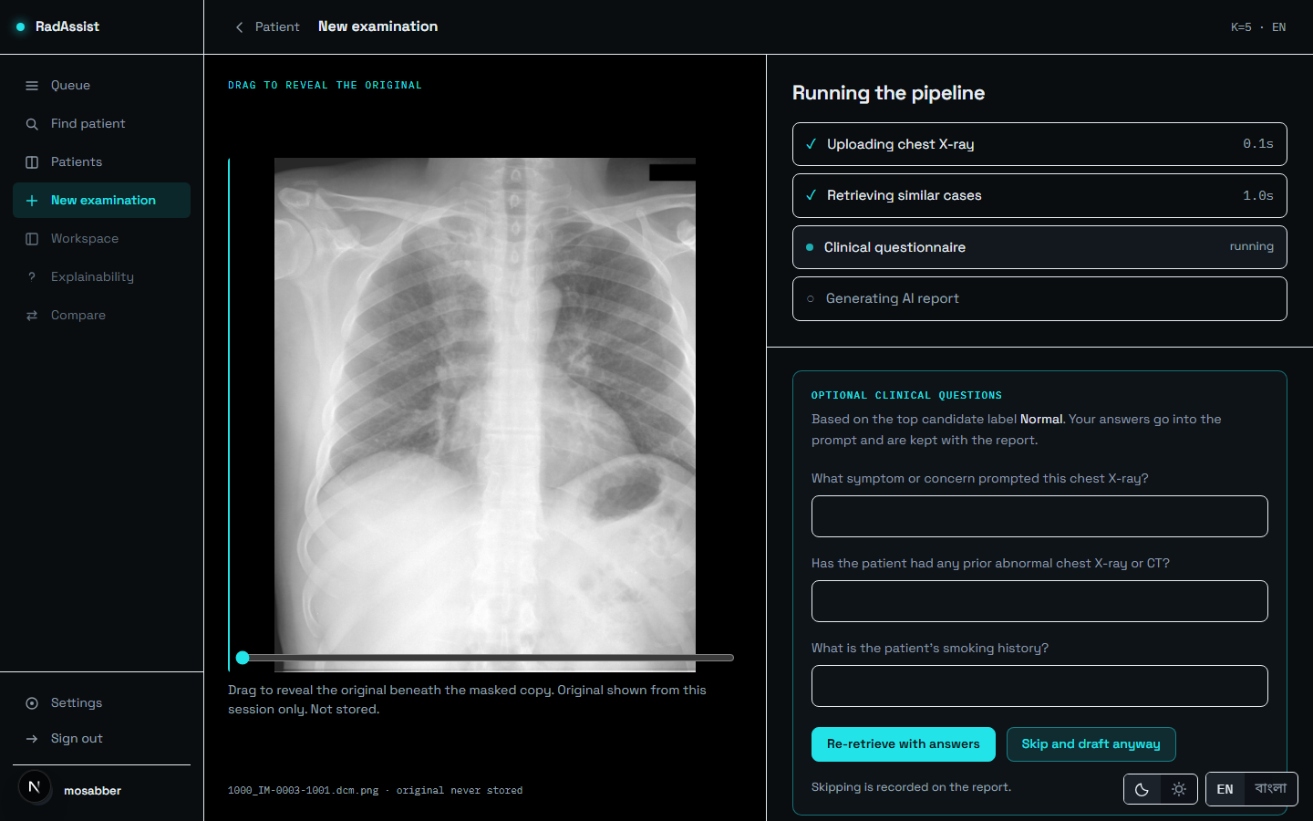
Figure 16: Generation in progress: four steps with live timings — uploading, retrieving, questionnaire, generating.
Source: 05_screenshots/11-generate-in-progress-dark.png — captured 2026-09-23 at 1440×900 from the running system.
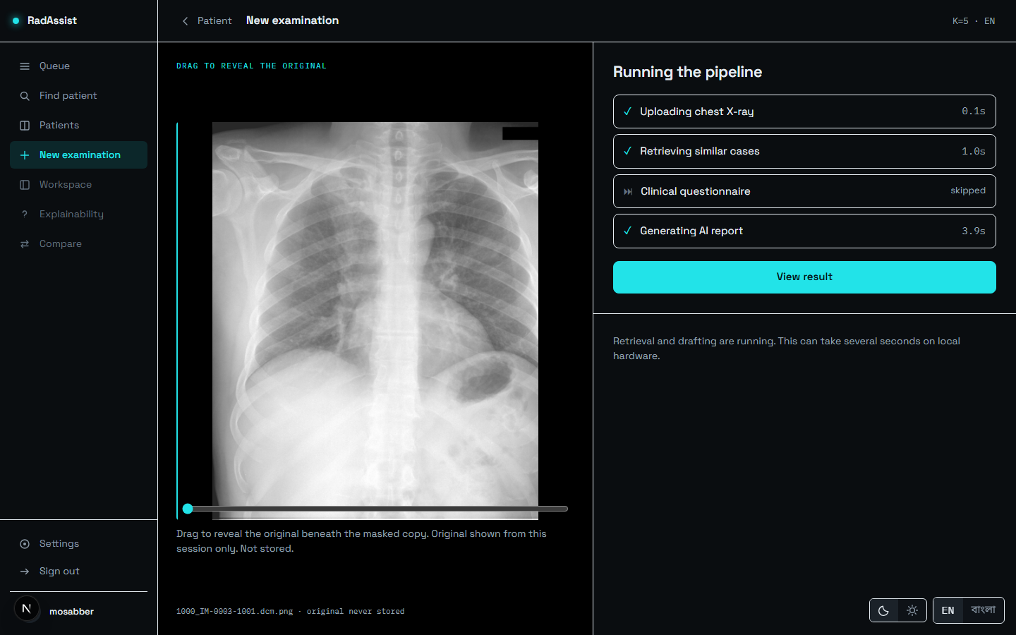
Figure 17: All four steps complete. In this captured run: upload 0.1 s, retrieval 1.0 s, questionnaire skipped, generation 3.9 s. This is one observation on one machine, not a benchmark.
Source: 05_screenshots/13-generate-complete-dark.png — captured 2026-09-23 at 1440×900 from the running system.

F-24 Declared projection (required)
Status: Implemented · Where: Upload screen · Interface: Form field on POST /retrieve
The doctor must declare PA, AP or LATERAL. This is not optional: the control to begin the examination stays disabled until a projection is chosen, and an absent declaration is a distinct coded rejection at the server rather than a silent default.
A lateral declaration is refused, because the system reports frontal chest radiographs only. LATERAL is declarable but not accepted on purpose, so declaring it produces a specific, separately coded rejection rather than an unrecognised-value error. Critically, that refusal happens before the image is masked, embedded or used to query anything — no work is done on a film the system will not report.
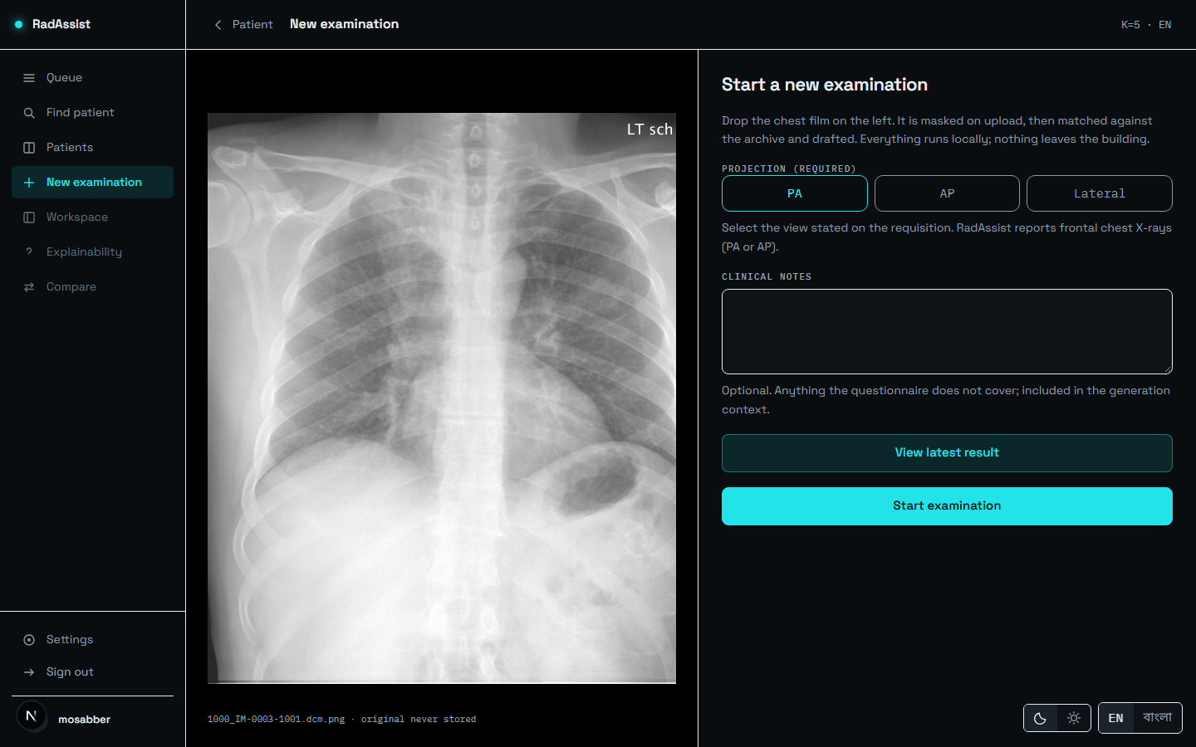
Figure 18: A film selected with the projection declared. Start examination stays disabled until a projection is picked. The PHI reveal slider (F-27) is the control over the image.
Source: 05_screenshots/10-upload-selected-dark.png — captured 2026-09-23 at 1440×900 from the running system.

F-25 Image admission gate (A1–A13)
Status: Implemented — blocks · Where: Server-side only · Interface: POST /retrieve, before anything expensive
Thirteen checks run before any model touches the file. In order: an extension allow-list; a magic-byte signature sniff; agreement between signature and extension; size bounds (20 kB to 20 MB); a verification pass followed by a second open to load; a pixel ceiling of 80,000,000 checked at three separate points as a decompression-bomb guard; dimension bounds (256 to 8192 px); and finally a re-encode from the pixel array alone.
That last check is the strongest control in the system. Whatever was uploaded, what proceeds is a PNG this process encoded: no metadata, no trailing bytes, no embedded payload. The raw uploaded bytes never reach disk at all — only the normalised PNG is written, and only its masked form survives the request.
The filename is read exactly once, for its extension, and is never stored. This is a privacy control rather than a tidiness one: a filename routinely contains a patient name, and an audit row or an error message carrying one would leak it. Nothing downstream can reference it, because nothing downstream has it.
Failures map to HTTP 415, 413 or 422 by an explicit table rather than a chain of handlers, so a missing or duplicated mapping is visible at a glance. No screenshot: this feature is server-side and its success is invisible. Its failures surface as a message on the retrieval step of Figure 12.

F-26 PHI masking
Status: Implemented · Where: Server-side, on every upload · Interface: EasyOCR detection, solid black boxes
Burned-in text is detected by OCR and masked with solid black boxes — never blur, never inpainting. Inpainting was rejected deliberately: it hallucinates plausible pixel content, which would be a strange thing for an evidence-grounded system to feed its own encoder. A solid box is an unambiguous null signal.
Masking runs before embedding, so the vector the system judges and stores is derived from the pixels the system is willing to keep. The masked file is written straight to its permanent location — one artefact, not two copies that could diverge — and on a rejected upload both copies are destroyed before the refusal returns.
The safety of masking is validated; its detection accuracy is not, and the two must not be conflated. Embedding impact was measured at a mean cosine similarity of 0.992 before and after masking across 50 images, with none falling below the 0.90 threshold — masking does not disturb diagnostic content. But the dataset carries no burned-in-PHI ground truth, so detection recall cannot be measured here. The recorded figure of 2,875 of 3,689 frontal images (77.9%) carrying at least one masked region is pipeline evidence, not a detection-performance metric.

F-27 PHI reveal slider
Status: Implemented · Where: Upload screen · Interface: Local browser object URL
A slider shows the uploaded original beside the masked copy, so the doctor can confirm that masking covered the text and nothing diagnostic. The original is drawn from a local browser object and is never uploaded or stored — the comparison happens entirely in the browser. Visible as the control over the film in Figure 11.

F-28 Modality gate
Status: Implemented — blocks · Where: Server-side · Interface: Softmax over BiomedCLIP text prompts
Answers is this a chest radiograph at all? by taking a softmax over a set of BiomedCLIP text prompts, using the model’s own learned logit scale as the softmax temperature rather than an invented one. A score below 0.60 refuses the upload.
The threshold is calibrated, not guessed: a false-negative budget of 0.02 was stated before any result was read, and the selected value achieves a frontal false-negative rate of 0.0000 across 300 images. A stricter 0.82 was considered and declined.
On refusal the masked image is unlinked, an audit row is written, and HTTP 422 is returned. The prompt vectors are encoded once, in the service constructor at application startup — that line is the cache, so no per-request encoding occurs.

F-29 Projection band gate
Status: Implemented — blocks · Where: Server-side, after retrieval · Interface: Threshold on top-1 similarity
Answers does this film match the projection that was declared? A top-1 similarity below 0.8500 is refused as a projection mismatch, with the audit row carrying the modality score alongside.
This threshold’s selection rule was revised post-hoc, and that is recorded in the source itself rather than presented as a pre-registered choice. The original rule took the midpoint of the observed separation gap, giving 0.8695. A genuine frontal radiograph from outside the dataset then scored 0.8582 and was wrongly rejected — it sits above every lateral in the calibration set but below that midpoint. The rule was changed to just above the observed lateral maximum, and re-verified on the same 600-study set: 300 of 300 laterals still rejected, 0 of 300 frontals rejected. It remains an observed separation point, not a validated boundary.
This gate is deliberately separate from the retrieval floor (F-34): one blocks, the other only categorises. Collapsing them into a single value would delete the middle band that the disclaimer and the evidence display both depend on.

F-30 Upload rejection audit
Status: Implemented · Where: Server-side · Interface: upload_rejection_log table
Every refused upload is recorded with its reason code, pipeline stage, SHA-256 hash, file size and declared extension — and never the filename. The hash allows a repeated bad file to be recognised without retaining anything identifying about it. No screenshot: there is no interface over this log.

Tier 5 Retrieval — the First Half of the Core
These features are the reason the system exists. Nothing here is trained: the encoder is frozen and the knowledge base is fixed.

F-31 BiomedCLIP image embedding
Status: Implemented · Where: Server-side · Interface: 512-dimensional vector
The masked image is encoded by BiomedCLIP into a 512-dimensional vector, L2-normalised so that cosine similarity reduces to a dot product for every downstream consumer. The encoder is frozen — no training of any kind occurs in this system.
The vector is computed once per upload and reused: the modality gate must not re-encode, so the route embeds explicitly and passes the vector to every consumer. The model loads once per process at startup, never per request.
The embedder is the single most deliberately shared component in the codebase: it lives outside both the research pipeline and the application so that offline knowledge-base embeddings and live query embeddings come from one implementation. Two copies with a subtle preprocessing difference would not raise an error — they would quietly place the two sets of vectors in slightly different spaces and degrade retrieval invisibly.

F-32 k-NN retrieval over the knowledge base
Status: Implemented · Where: Server-side · Interface: ChromaDB, top_k default 5
The query vector retrieves the five most similar archived studies from a ChromaDB collection of 2,462 documents, each carrying its real findings and impression text directly in the record — so retrieval returns evidence text without a second lookup.
The collection is the training split only, and it is leakage-controlled twice over. At study level, one row per study, so a study’s own second view cannot become its own neighbour. And by near-duplicate clustering: roughly 28% of studies in this corpus sit in a cluster of near-identical report text, and clusters rather than studies are the atomic unit of the split. A query case can therefore retrieve neither itself nor its own near-duplicate.
The number retrieved is the doctor’s k preference (F-13).

F-33 Label voting and agreement
Status: Implemented · Where: Server-side · Interface: Similarity-weighted vote
A similarity-weighted vote over the retrieved cases’ curated labels produces, for each candidate label, a weight and an agreement fraction. These are what the evidence panel displays and what conditions the questionnaire.
These are not predictions. No classifier exists anywhere in this system; the voted labels summarise what five real archived cases were labelled with. The distinction is the project’s central design commitment — a classifier produces a number, retrieval produces evidence a reader can open.
The votes are computed at generation time and then stored, not recomputed on read, so the evidence state cannot change after the report exists.

F-34 Retrieval support signal
Status: Implemented · Where: Evidence page · Interface: Computed server-side, stored with the report
Classifies retrieval support as at or above the floor or below the floor, against a calibrated retrieval floor of 0.8906208872795105. Unlike F-29 this never blocks — it sets a category that reaches the disclaimer, the stored report record and the evidence display.
The value is computed by the backend and the frontend is required not to re-derive it, so the interface cannot disagree with the stored record.
One honest caveat: the low-support branch was never exercised during calibration — 0 of 300 frontal cases fell below the floor. The mechanism is built and correct but was not observed firing on the calibration set.
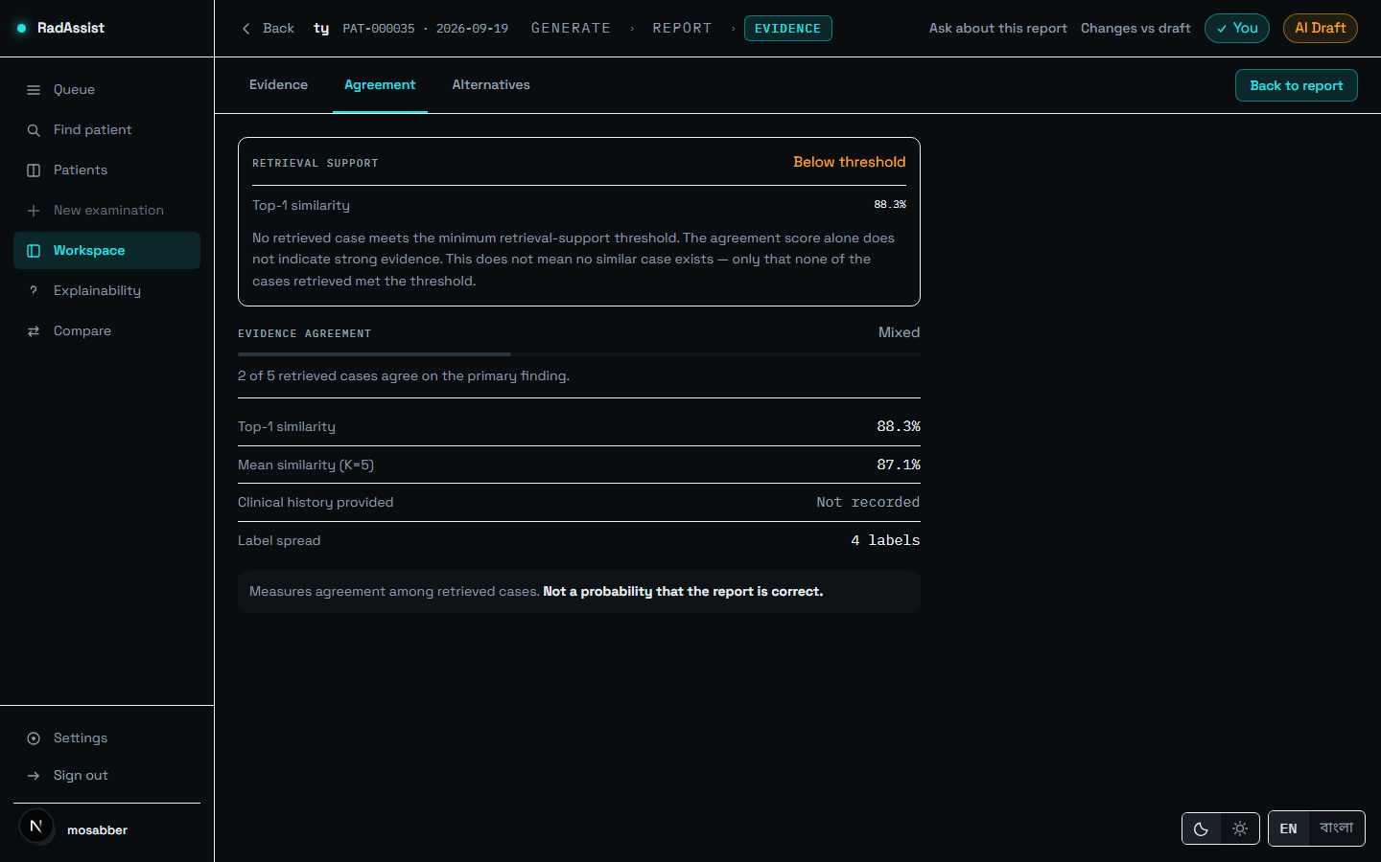
Figure 19: Retrieval support reading “Below threshold” at a top-1 similarity of 88.3%. The notice states its own limit: this does not mean no similar case exists, only that none retrieved met the threshold.
Source: 05_screenshots/17-evidence-below-floor-dark.png — captured 2026-09-23 at 1440×900 from the running system.

F-35 Query image replay
Status: Implemented · Where: Report and evidence screens · Interface: GET /retrieval-sessions/{id}/image
Serves the masked query image of any past session, which is what the report screen displays beside the draft. The original is never stored, so the masked copy is the only image the system can ever show — a property, not a limitation.

Tier 6 Generation — the Second Half of the Core

F-36 Clinical questionnaire
Status: Implemented · Where: Within the upload flow · Interface: GET /questionnaire/{session_id}
Between retrieval and generation the system offers short clinical questions conditioned on the top voted label — so the questions asked depend on what was actually retrieved rather than being a fixed form. Answers feed the generation prompt.
It is skippable, and a doctor can make skipping their default (F-13). The panel is deliberately prominent and scrolls itself into view: it is the one moment the pipeline stops and waits for the reader.
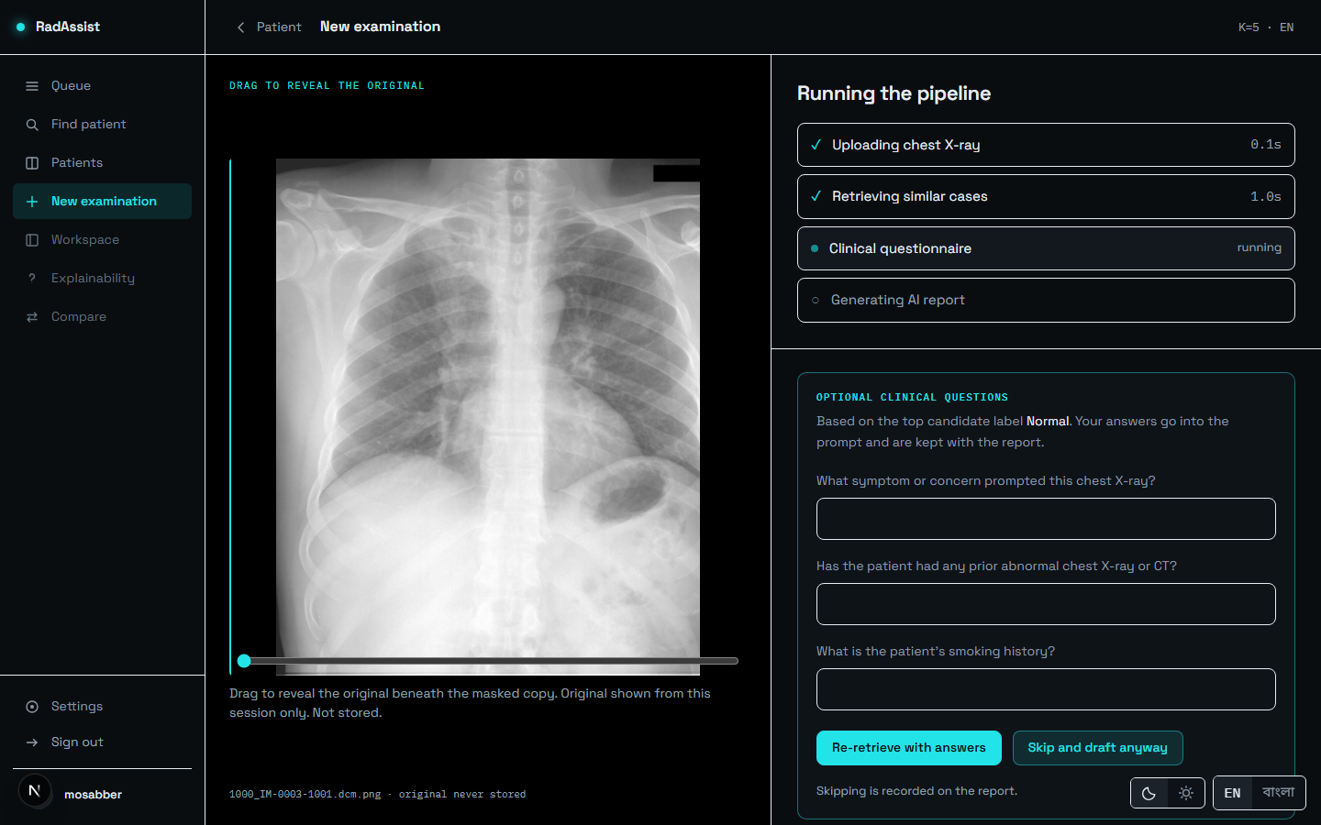
Figure 20: The clinical questionnaire, conditioned on the retrieved findings. It can be skipped.
Source: 05_screenshots/12-questionnaire-dark.png — captured 2026-09-23 at 1440×900 from the running system.

F-37 Clinical notes
Status: Implemented · Where: Upload screen · Interface: Field on POST /generate-report
Free text for “anything the questionnaire does not cover; included in the generation context”. It is persisted with the report. The API had always accepted this field; the interface passed an empty string until the final phase, so it reaches generation for the first time in this build.

F-38 Report generation (seven fields)
Status: Implemented · Where: Server-side · Interface: POST /generate-report, llama3:8b via Ollama
The principal feature. The retrieved reports’ text, the voted labels with their agreement, the questionnaire answers, the clinical notes and the language instruction are assembled into a prompt of nine sections in fixed order, and a locally hosted 8-billion-parameter model drafts the seven fields: Examination, Clinical History, Technique, Findings, Impression, Recommendation and Disclaimer.
The image never reaches the language model. Generation is text-only; the image’s entire contribution is the 512-dimensional vector that selected the five neighbours. The prompt peaks at 1,574 tokens of a 4,096-token window, so the evidence block is never truncated — a failure that would silently drop evidence without being visible in the output.
The evidence assembly performs no diagnosis and no synthesis: it sorts by descending similarity with a deterministic tie-break, collapses near-duplicates, and partitions evidence per label. Any judgement it made would be a clinical judgement made by a component with no way to explain itself.
Measured latency is 4.50 s mean per report over 477 cases, with the whole stack peaking at 7,125 MiB of 16,376 MiB of GPU memory.

F-39 Structural validation and content retry
Status: Implemented — the only check that blocks · Where: Server-side · Interface: Two content retries, then HTTP 422
Parses the seven delimiter-marked fields. On a structural failure it builds a correction prompt carrying the rejected response and the specific errors and calls again, up to twice. On exhaustion it returns HTTP 422 carrying the last raw response and the error list, so the failure shows what went wrong rather than a bare status.
The marker format is itself a finding. The output was originally JSON, and 17 of 477 generations failed — all 17 to a single cause: the model inconsistently quoting label names inside the disclaimer field’s JSON string, breaking parsing at that boundary. Delimiter markers remove the nested-string boundary a stray quote can break, for that field and every other. 1,777 generations since have produced zero structural failures.
One qualification applies to that zero: it means zero failed after retries, never zero needed a retry. The attempt count is not persisted anywhere, so how many required a second or third attempt is unknown.

F-40 Semantic validation
Status: Implemented, advisory — gates nothing · Where: Shown on the report page · Interface: Warnings persisted with the report
Warns on empty sections, on terms unsupported by the retrieved evidence, and on a top voted label not reflected in the report text. Warnings render in an amber block on the report screen, outside the collapsible disclosure.
It is advisory by design, and the reasoning is specific. A validator that blocks must be right; one that advises may be conservative. This one flags terms absent from the evidence, and a correct report can legitimately use a term its neighbours did not — so blocking on it would refuse good reports.
Two limitations are recorded rather than implied. It concatenates findings and impression before inspecting them, so a contradiction between those two sections is not representable in it at all. And a finding copied from a neighbour is structurally exempt from its unsupported-terms check, because a copied finding is by definition present in the evidence. These two gaps are precisely why F-42 exists.
A warning always describes the AI draft, never the doctor’s edited text. Warnings are computed once, at generation, and are not recomputed on edit.
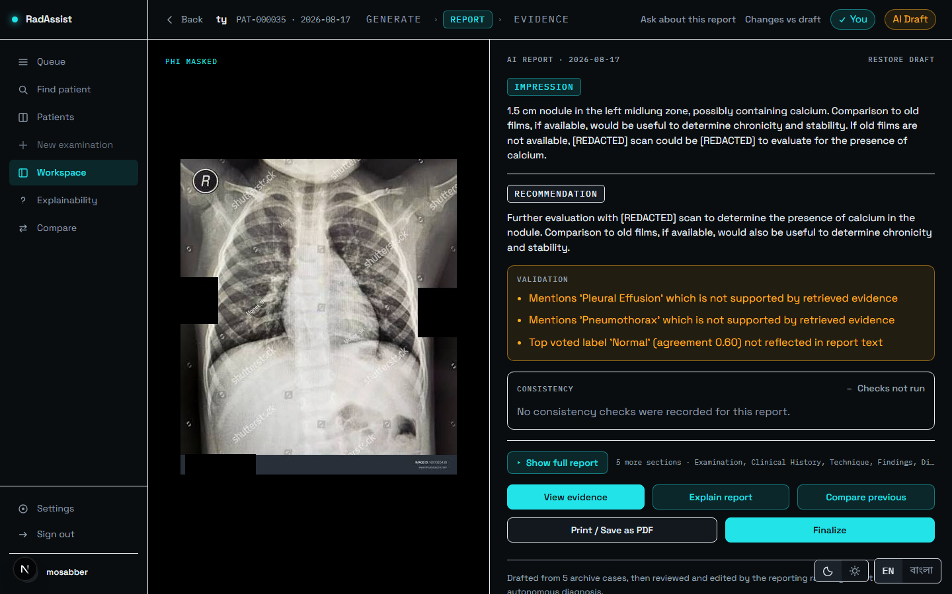
Figure 21: A report carrying three validation warnings. The consistency block here reads “checks not run” — this is a pre-v1.2 report.
Source: 05_screenshots/16-result-warnings-dark.png — captured 2026-09-23 at 1440×900 from the running system.

F-41 Server-authored disclaimer
Status: Implemented · Where: Every report · Interface: Server template replaces the model’s text
The provenance line — “Drafted from 5 archive cases, then reviewed and edited by the reporting radiologist. Not an autonomous diagnosis” — is written by the server and replaces whatever the model produced in that field.
The replacement is deliberate and there is a recorded failure behind it. A model-authored disclaimer once cited only the agreement score — the real sample read “Clinical uncertainty due to low agreement score (0.60)” — while retrieval support is an independent signal that can disagree with it: five cases can all fall below the floor while carrying the same label, making agreement high and support low. A disclaimer reading one signal would reassure in exactly the case warranting caution. The server template reads both.
It is rendered after semantic validation on purpose, because handing the validator a server-authored string would be validating this system’s own template output as though it were generated content.

F-42 Consistency checking (three checks, four states)
Status: Partial — see below · Where: Report page · Interface: Observational: it alters nothing
After generation, three checks examine the draft: a temporal check for comparison language where no prior study exists, a transplant check for text copied from a retrieved neighbour, and a contradiction check that labels findings and impression separately and compares them. The verdict is stored and displayed.
The service is observational — it records what it found and changes nothing the model wrote. This is asserted by test: the same model output, generated with and without the service injected, produces byte-identical persisted content. It costs 6.9–7.8 ms per report, about 0.2% of request latency.
The four states are rendered by four separate components, deliberately not by one component parameterised by a colour lookup — because the parameterised version is the one in which a later edit silently gives the not-run state the appearance of a pass.
Table 3: The four consistency states and what each licenses a reader to conclude.
Source: 01_facts/amendment_01_consistency_status.md §2.
State | Meaning | Reachable in this build?
Violations | A check found a problem. The actionable state. | Yes — 17 of 477 in the evaluation run.
Partially checked | Some applicable checks ran, at least one did not. The label names both halves. Not a pass. | Yes — every English report.
Checks not run | Nothing was assessed — a Bengali report, or one predating the checks. Not a pass. | Yes.
Clean | Every applicable check ran and found nothing. The only genuine pass. | No — unreachable. See below.
Why this feature is marked Partial. The transplant check computes its scores but can emit no violation, because no threshold has been calibrated for it. It is therefore never listed among the checks that ran, which makes the set of completed checks a strict subset of the applicable set for every English report — so *every English report reads Partially checked, and Clean is unreachable*. This is correct rather than unfortunate: one of three checks genuinely is not operational, and the earlier behaviour asserted a completeness the system does not have.
A second gap: nothing acts on a violation. A retry count exists in configuration and is read by no service. In the evaluation run, 17 of 477 recorded violations were acted on by nothing.
*A non-English report shows Checks not run with its reason, never a blank. Showing nothing at all is read by a clinician as nothing wrong*, which would convert an acknowledged coverage gap into an affirmative false assurance.
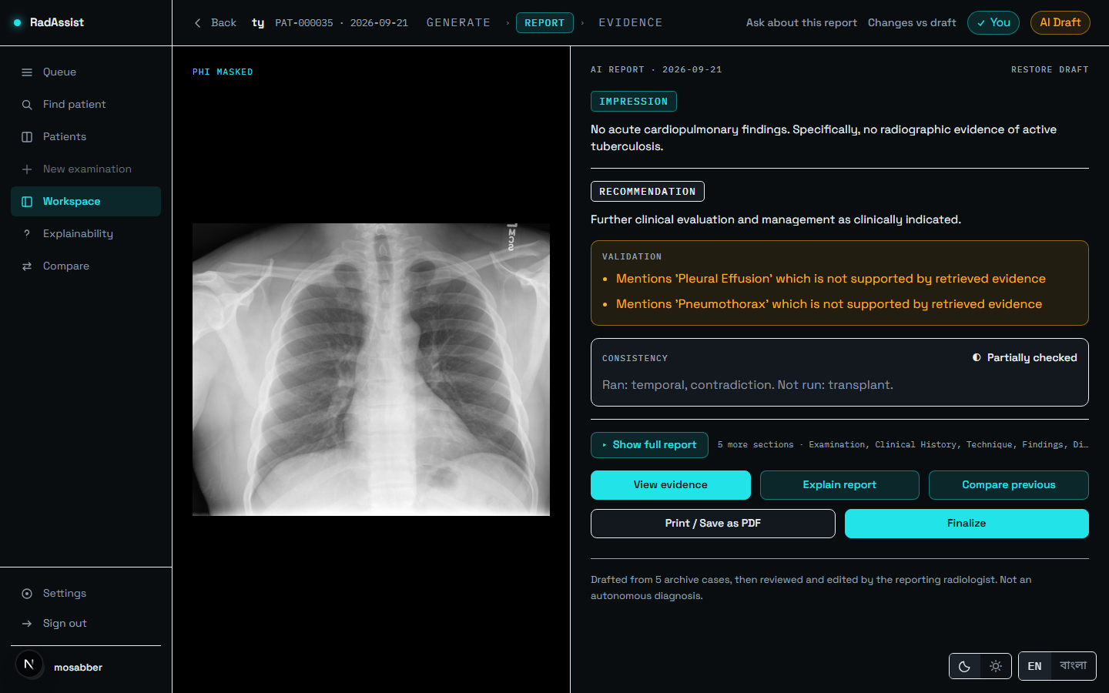
Figure 22: “Partially checked” — the state every English report reaches. The label names both halves: which checks ran and which did not.
Source: 05_screenshots/14-result-partial-dark.png — captured 2026-09-23 at 1440×900 from the running system.
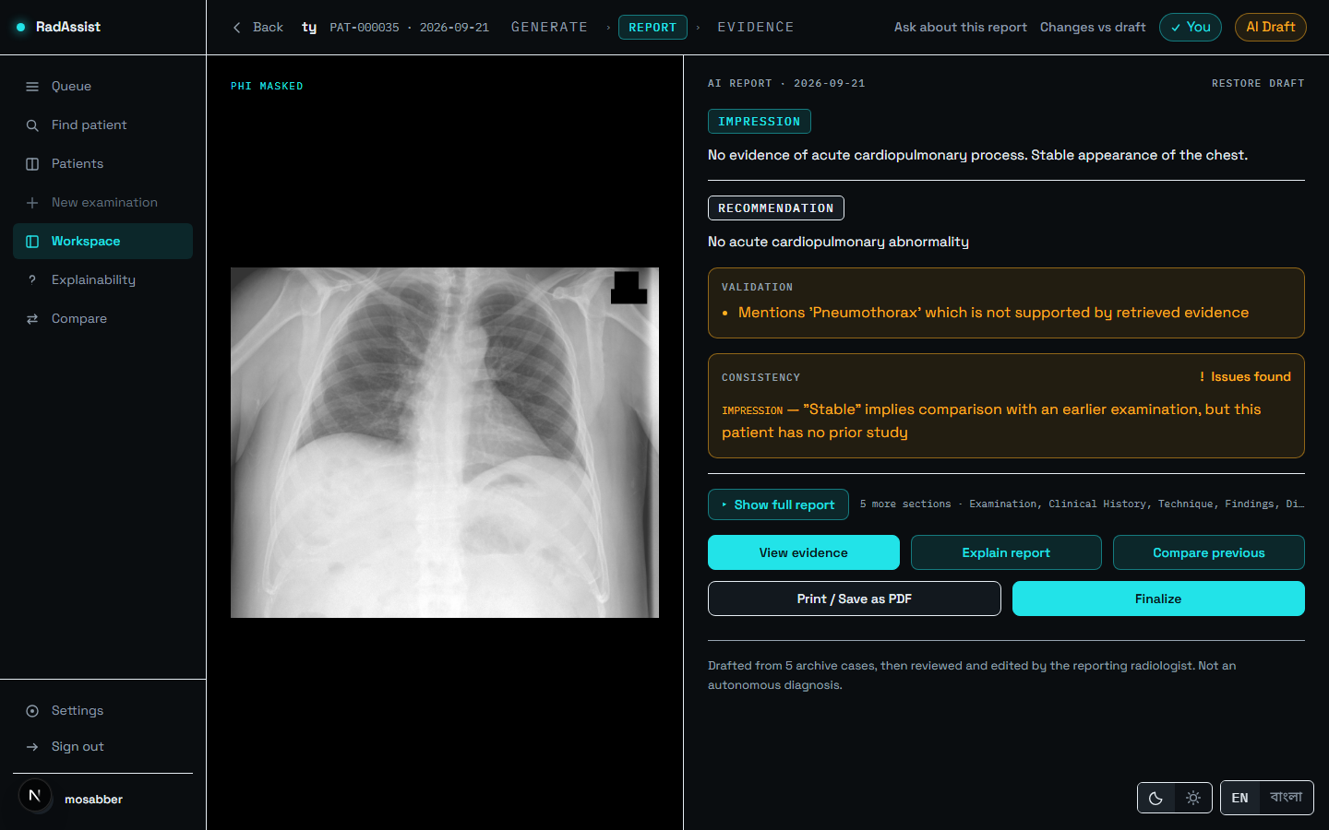
Figure 23: “Violations” — a temporal-check violation raised on a report with no prior study. Nothing is corrected automatically.
Source: 05_screenshots/15-result-violations-dark.png — captured 2026-09-23 at 1440×900 from the running system.

Tier 7 Review and Authorship
The features that make the clinician the author rather than the recipient.

F-43 Report page, summary first
Status: Implemented · Where: Route /workspace/{id}/report · Interface: Step 2 of three
Impression and recommendation, the validation block and the consistency verdict all render before, and outside, the collapsible disclosure — in every state. The conclusions a radiologist opens the screen to read are never behind a control, and neither are the alerts.
An earlier build rendered all seven fields as one flat document in canonical order, which put the impression fifth and the warnings below all seven — below the fold on any report with a long findings section.
Figure 24: The report page: summary first, with the masked film alongside.
Source: 05_screenshots/14-result-partial-dark.png — captured 2026-09-23 at 1440×900 from the running system.
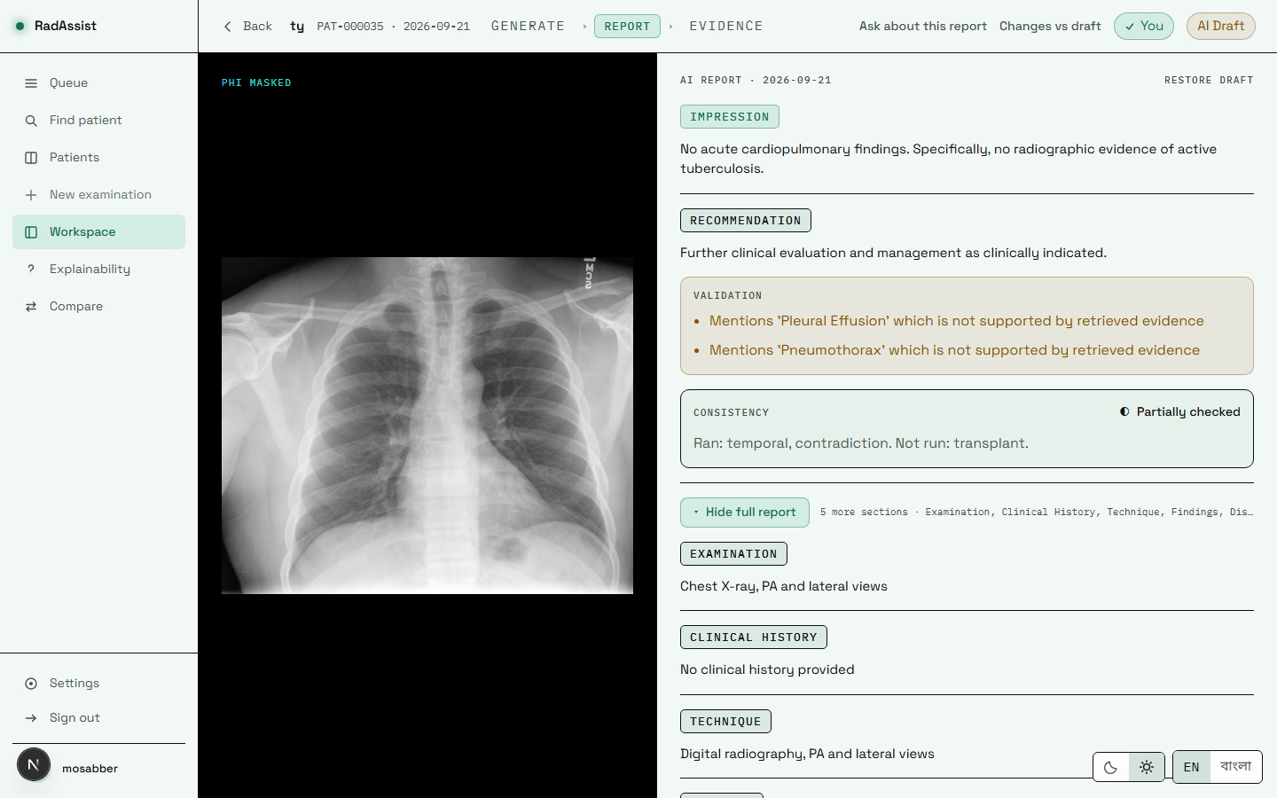
Figure 25: The same report page in the light theme.
Source: 05_screenshots/31-result-partial-light.png — captured 2026-09-23 at 1440×900 from the running system.

F-44 Full-report disclosure
Status: Implemented · Where: Report page · Interface: All seven fields
Show full report reveals the remaining five fields. The two field lists are derived by partitioning the canonical seven-field list rather than being restated, so a field added to the canonical list lands in the full report automatically instead of silently appearing in neither half.
Four states force the disclosure open and disable its own control: a section being edited, a regeneration in flight or awaiting a decision, the finalize preview, and printing. The rule lives in its own module with a test per case, because a safety rule that exists only inside a render is one nobody can point at.
Nothing unmounts on collapse — the content is hidden rather than removed, which takes it out of the accessibility tree and the tab order. A height-based collapse would leave a screen-reader user hearing five sections a sighted reader was told are closed.
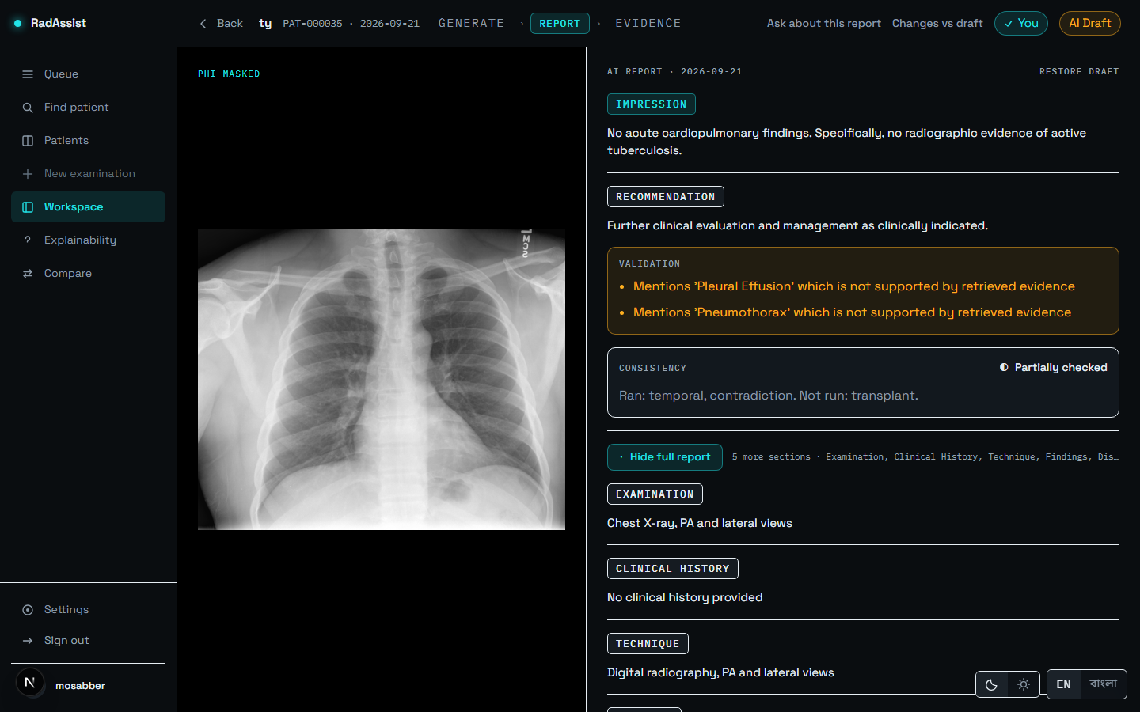
Figure 26: The full report expanded: Examination, Clinical History, Technique, Findings, Impression, Recommendation and Disclaimer.
Source: 05_screenshots/18-full-report-expanded-dark.png — captured 2026-09-23 at 1440×900 from the running system.

F-45 Section editing
Status: Implemented · Where: Report page · Interface: PATCH /reports/{id}
Five of the seven fields are editable — clinical history, technique, findings, impression and recommendation. Examination and Disclaimer are set once by the system and are not editable: the first is metadata, the second is the provenance statement of F-41, which the doctor must not be able to weaken any more than the model can.
Editing moves the report from AI Draft to Doctor edited. Owner only; refused once finalized.

F-46 Section regeneration
Status: Implemented · Where: Report page · Interface: POST /reports/{id}/regenerate-section
Regenerates one section as a candidate the doctor explicitly accepts or discards — it never overwrites in place. While a candidate is pending, the disclosure is held open and its control disabled (F-44).
Regeneration receives the report’s current findings when regenerating the impression or recommendation. An earlier build did the opposite: it omitted the report’s own content and instructed the model not to consider other sections, which is precisely the condition that lets a regenerated impression contradict the findings above it.

F-47 Word-level diff
Status: Implemented · Where: Report page · Interface: Changes vs draft
Shows word-by-word what the doctor altered against the original AI draft, so the human contribution to a finalized report is legible rather than lost. Its section order follows the canonical editable field list.

F-48 Finalize
Status: Implemented · Where: Report page · Interface: PATCH /reports/{id}/finalize
Moves the report to Final, stamping who finalized it and when, and writing an audit row. A preview is shown first.
Finalizing is a one-way door. Afterwards, edits are refused with HTTP 409 regardless of ownership, and deletion is refused too — a signed report is an audit record, and erasing one would erase the evidence that it was signed.
The status is consequential beyond the screen: the signature block prints only on a finalized report (F-57), because a draft is not a signed document and a name printed under one would claim otherwise on a page that outlives the status chip.

F-49 Delete report
Status: Implemented · Where: Queue row control · Interface: DELETE /reports/{id} → 204
Owner only, and refused with 409 once finalized. Dependent audit-log, explanation and comparison rows — from either side of a comparison — are removed explicitly rather than by database cascade, because the database does not enforce foreign keys by default here and a cascade would appear to work while orphaning rows.
The control is two-step and is revealed on row hover only where hover actually exists, so it is neither accidental nor unreachable on a touch device.

F-50 Report edit audit
Status: Partial · Where: Server-side · Interface: report_audit_log table
Records edit actions against a report and the doctor who made them. Partial because there is no general audit trail: no login, read or export events are recorded anywhere in the system. The two logs that exist are this one and the upload rejection log (F-30).

Tier 8 Evidence and Downstream Tools
The features that make the draft inspectable rather than merely present.

F-51 Evidence tab
Status: Implemented · Where: Route /workspace/{id}/evidence · Interface: Step 3 of three
Lists the five retrieved neighbour cases with their real similarities. This is the provenance of the draft: every statement in the report was built from these cases, and the doctor can read them.
The similarities shown are the real ranked values, restored from the persisted evidence rows rather than recomputed. Re-fetching a case from the vector store by identifier is an unranked lookup that reports a sentinel similarity of 1.0 for every case; three consumers once treated that sentinel as a measurement, and the interface showed 100% on every case. The restore is keyed by identifier rather than zipped positionally, because the lookup can return fewer rows than were requested.
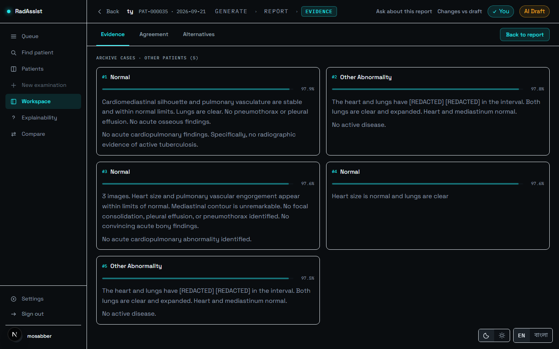
Figure 27: The Evidence tab: the five retrieved neighbour cases and their similarities.
Source: 05_screenshots/19-evidence-tab-evidence-dark.png — captured 2026-09-23 at 1440×900 from the running system.
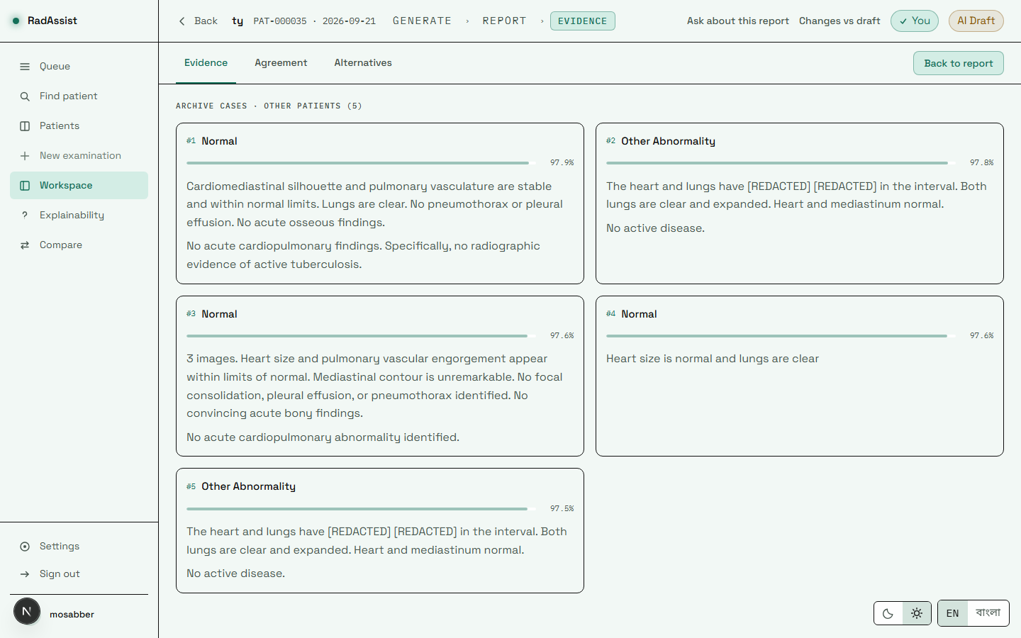
Figure 28: The evidence page in the light theme.
Source: 05_screenshots/32-evidence-light.png — captured 2026-09-23 at 1440×900 from the running system.

F-52 Agreement tab
Status: Implemented · Where: Evidence page · Interface: Derived from the held report object
Shows retrieval support (F-34), top-1 and mean similarity, and how many of the retrieved cases agree on the primary finding.
The panel states its own limit at the point of use: “Measures agreement among retrieved cases. Not a probability that the report is correct.” Five cases can agree with one another and all be unlike the patient in front of the reader. Putting that caveat on the panel rather than in documentation is deliberate — it is read where the number is read.
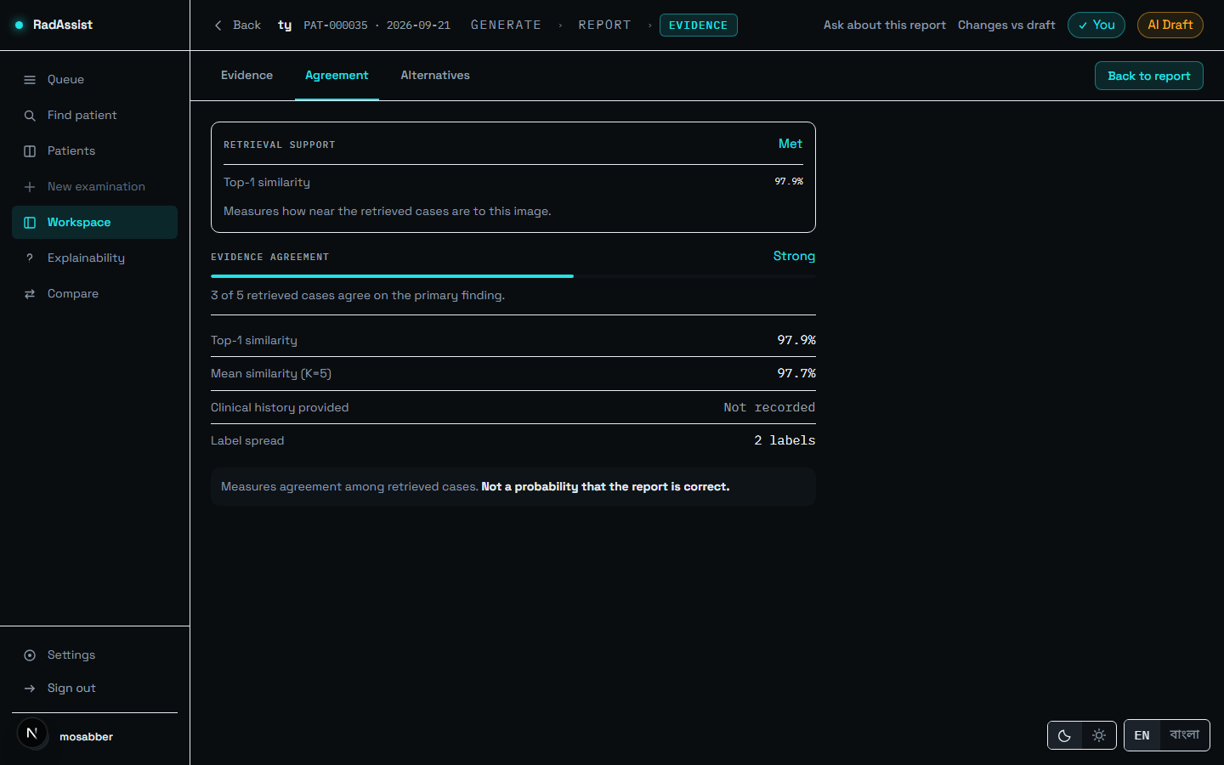
Figure 29: The Agreement tab: retrieval support, top-1 and mean similarity, and agreement among retrieved cases, with its own caveat.
Source: 05_screenshots/20-evidence-tab-agreement-dark.png — captured 2026-09-23 at 1440×900 from the running system.

F-53 Alternatives tab
Status: Implemented · Where: Evidence page · Interface: Derived from the held report object
The labels that did not win the vote. This exists so that the vote is legible as a vote rather than as a verdict: a reader can see what else was present in the retrieved evidence and how close it came.
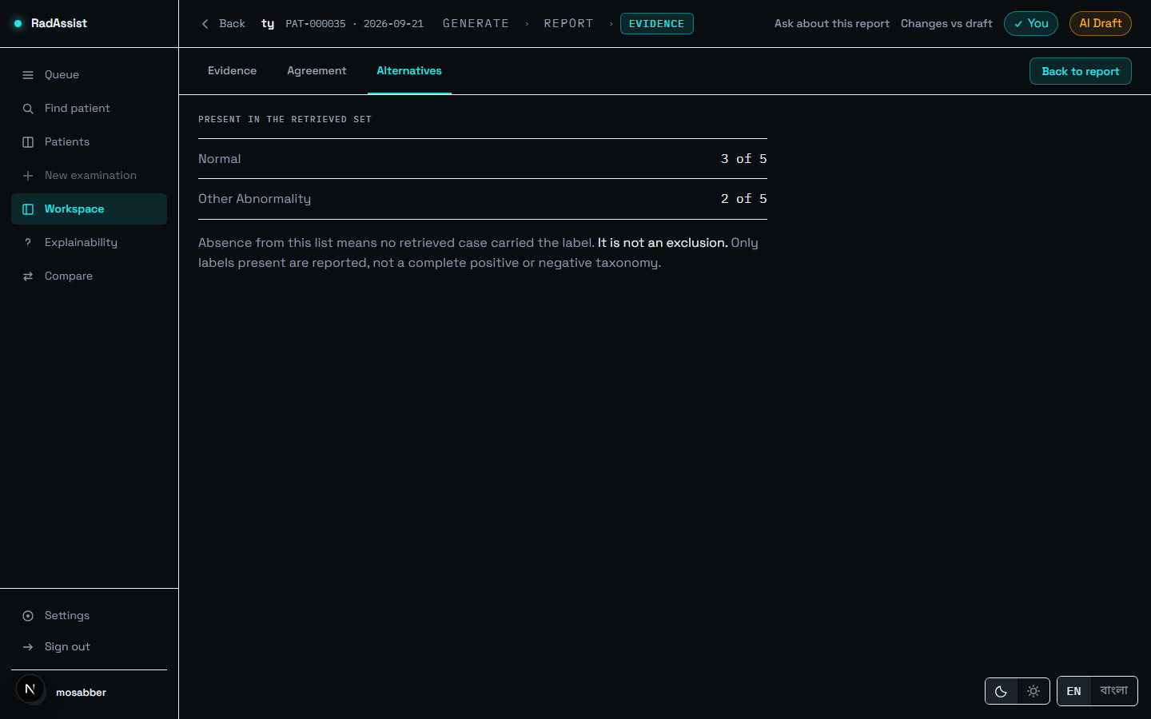
Figure 30: The Alternatives tab: labels that did not win the vote.
Source: 05_screenshots/21-evidence-tab-alternatives-dark.png — captured 2026-09-23 at 1440×900 from the running system.

F-54 No-refetch navigation guarantee
Status: Implemented · Where: Workspace routes · Interface: Segment layout owns the fetched report
Moving between Report and Evidence fires no network request — not because a cache answers it, but because nothing asks again. The segment layout holds the fetched report and both pages read the same object; the evidence page fetches nothing at all.
The distinction matters: a cache satisfies this conditionally, correct until invalidated wrongly, and every mutation is an opportunity to get that wrong. Hoisting the fetch satisfies it unconditionally, because the child routes have no loader to call.
Proven twice: a component test asserts the fetch count and a mount counter are unchanged when the child swaps, and a real-browser harness counted report requests across a Report → Evidence → Report round trip and recorded zero, with the active tab surviving and both back and forward behaving correctly.

F-55 Explainability assistant
Status: Implemented · Where: Route /reports/{id}/explain · Interface: POST /reports/{id}/explain
Ask a question about a finished report and receive an answer grounded on the same evidence block the report itself used. Suggested questions are offered, and the cases in context are listed with their similarities.
The assistant cannot introduce new findings and is not a second opinion — the screen says so. Questions and answers persist with the report as part of its audit trail, so what was asked about a report travels with it.
One limitation is recorded: the explainability prompt was changed by the grounding work and its output has never been evaluated by any endpoint in the project.
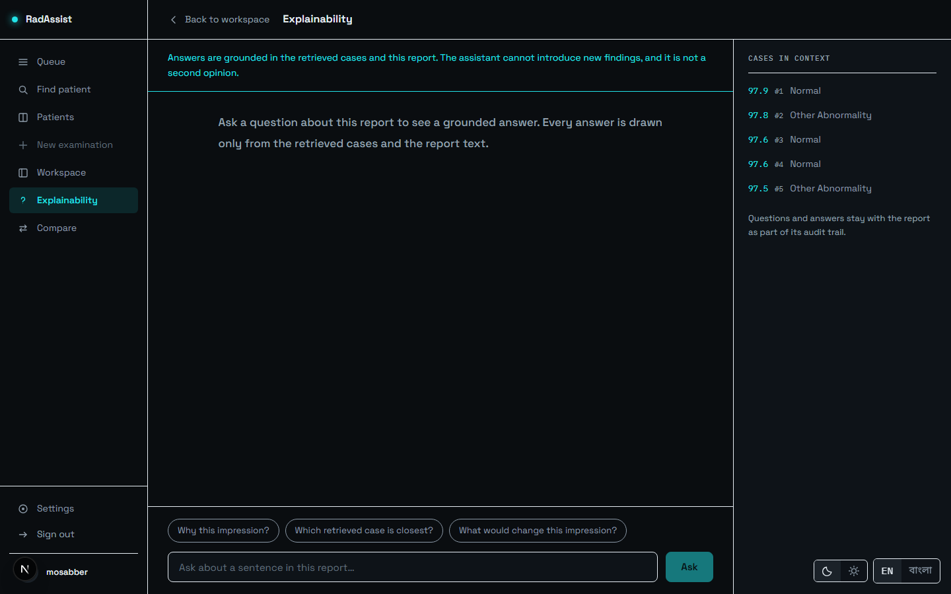
Figure 31: The explainability screen before a question: suggested questions, and the cases in context with their similarities.
Source: 05_screenshots/22-explainability-idle-dark.png — captured 2026-09-23 at 1440×900 from the running system.
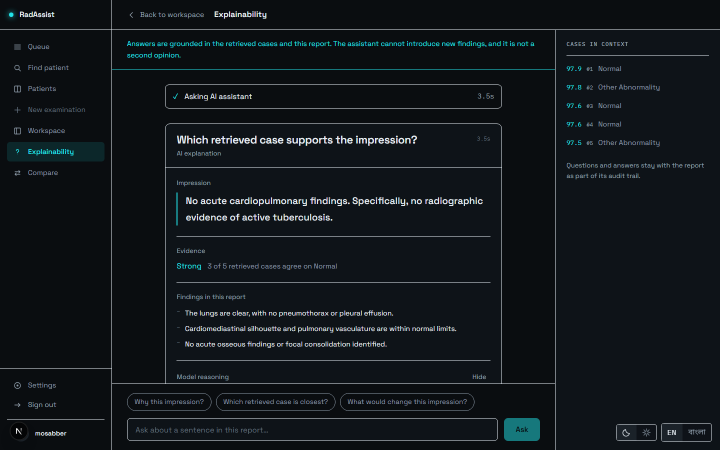
Figure 32: An answered question: the impression, the evidence strength, and the findings the answer rests on.
Source: 05_screenshots/23-explainability-answered-dark.png — captured 2026-09-23 at 1440×900 from the running system.

F-56 Longitudinal comparison
Status: Implemented · Where: Route /reports/{id}/compare · Interface: POST /comparisons
Compares a study against a prior study for the same patient, showing both films side by side with their impressions. Any prior study may be chosen, not only the most recent.
The split is computed deterministically and the model only narrates it. Resolved, persistent and new findings are derived by a deterministic comparator with no model involvement; the narrative is then written from that split only. The provenance line at the foot states which part is which: the change itself is not decided by the model. This is the sharpest division of labour in the system — the clinically consequential judgement is code, and the prose is the model’s.
A known defect is visible in the figure: the interval reads “-2 DAYS APART”, a negative value, because the prior study in the seeded capture data is dated after the current one. The comparison itself is computed correctly; the guard against a reversed ordering is missing.
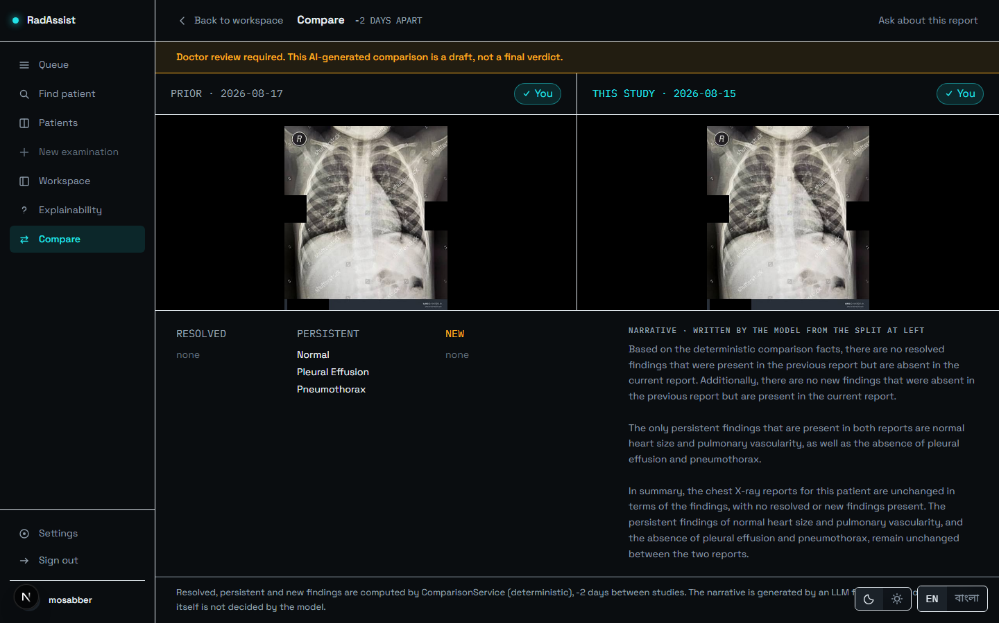
Figure 33: Comparison: both films with their impressions, the resolved / persistent / new split, and the narrative written from that split only. Note the negative interval — a known missing guard.
Source: 05_screenshots/24-compare-dark.png — captured 2026-09-23 at 1440×900 from the running system.

Tier 9 Output

F-57 Print / Save as PDF
Status: Implemented — browser print, client-side only · Where: Any workspace route · Interface: window.print()
Produces a complete clinical document: header, all seven fields, and the validation and consistency blocks. The doctor chooses Save as PDF in the browser’s own dialog.
The printed page is a second render, not the screen re-styled. This is the decision the rest follows from. A print stylesheet would make the printout’s completeness a function of interface state — one stale selector after a layout change and a report silently prints five sections short, with nothing to indicate it. The print document is built from the canonical seven-field list, takes no “collapsed” parameter, and a test asserts its arity so that none can be added.
Paper is not a theme: the print tokens sit outside both palettes, so a report printed from dark mode comes out black on white like every other document in the hospital. Pagination is A4 with 16 mm / 14 mm margins; headings never strand at a page foot; the running header repeats.
What always prints: the validation warnings and the consistency verdict, in every state. What prints conditionally: the signature block, only on a finalized report.
Honest labelling: the control reads “Print / Save as PDF (browser)”. It replaced a disabled stub labelled “Download PDF” — a control naming a capability the system did not have. There is no server-side PDF generator (F-61); the file is produced by the browser, so its pagination and fonts are the browser’s. The control is disabled when the report has no narrative content, because a report with none prints as a letterhead and a disclaimer — which looks official and says nothing.
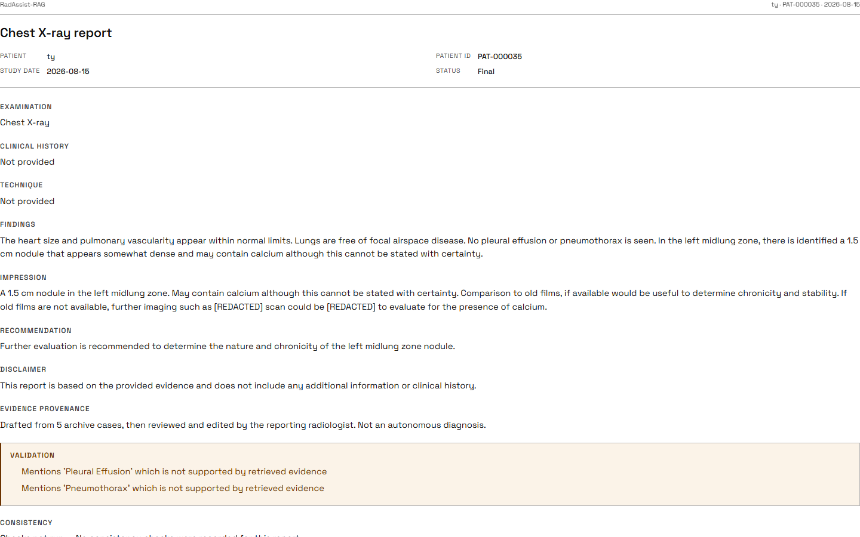
Figure 34: Print / Save as PDF: header, all seven fields, and the validation and consistency blocks.
Source: 05_screenshots/25-print-preview-dark.png — captured 2026-09-23 at 1440×900 from the running system.

F-58 Bengali print
Status: Implemented, and verified by rasterisation · Where: Print path · Interface: Self-hosted Bengali font subset
A Bengali report prints correctly, with Bengali section headings and the Bengali consistency reason.
This was verified by rendering the page and looking at it, not by counting characters — the distinction matters: a missing font subset produces empty boxes while leaving the text layer perfectly intact, so a character count would pass while the page was unreadable. The measured result was 9 sections and 781 Bengali codepoints with conjuncts correct and no missing glyphs. It works because the Bengali font is self-hosted through the framework’s font pipeline with the Bengali subset — which was a hypothesis until a page was actually rasterised.
One asymmetry remains: the Bengali printout’s validation warnings appear in English, because those strings are composed by the backend (F-09).

Tier 10 Deliberately Not Implemented
Ten capabilities that a reader might reasonably expect and that this build does not have. Each is listed with its reason. None is silently absent, and none should be demonstrated or promised.
Table 4: Capabilities not implemented, and why.
Source: 01_facts/feature_catalogue.md §7; 08_admin/open_items.md.
# | Capability | Why not
F-59 | BMDC licence verification | There is no BMDC registry this system can reach. The number is recorded exactly as entered, and the registration form is required to say so rather than imply verification.
F-60 | Administrator role / RBAC | No role column exists on the doctors table and no role-based authorisation exists anywhere. Access control is ownership only (F-07), and nothing in the delivered system needs an actor above that — which is why no administrator appears in the use-case model either.
F-61 | Server-side PDF export | Would require a server renderer, a template language, a document store and — the genuinely hard part — a server-side Bengali font stack. Browser print (F-57) reaches paper without any of it. No export route and no PDF library exist.
F-62 | Calibrated transplant threshold | Calibrating it needs a labelled set this project does not have. Rather than invent a number, none is passed. *Visible consequence: no English report can read Clean * (F-42).
F-63 | Automatic correction of a consistency violation | The scope of the current stage was explicitly observational: measure the check’s effect while it changes nothing. The retry count exists in configuration and is read by no service. 17 of 477 recorded violations were acted on by nothing.
F-64 | Password reset / forgot password | No reset-token storage and no mail transport, and self-registration already performs no email verification. Recorded as a scope boundary rather than left implicit.
F-65 | Image explainability (saliency / Grad-CAM) | Deferred on ethical grounds. There is no localisation ground truth here against which a heat map could be validated, and an unvalidated localisation displayed beside a validated evidence panel would invite trust in the wrong place. What ships instead is the evidence itself (F-51–F-53) — a record of provenance rather than an inference.
F-66 | Near-duplicate de-duplication at retrieval time | Documented as a future extension point and not implemented; near-duplicates are collapsed afterwards during evidence assembly instead.
F-67 | Translation pass | Permanently unimplemented by design: Bengali is generated directly, so there is no translation to prompt for.
F-68 | Multi-label sets in the retrieve response | Multi-label parsing is an open item, so that field is currently a single degenerate value.

Summary
Table 5: Feature counts by status.
Source: This document.
Status | Count
Implemented and working end to end | 53
Implemented but advisory or observational (F-40, F-42) | 2
Partial — a named part does not work (F-42, F-50) | 2
Implemented but never evaluated (F-09, F-58 Bengali path) | 1 feature area
Not implemented, with reasons (F-59–F-68) | 10
Three qualifications apply to this catalogue as a whole, and they belong with any presentation of it:
- No clinician has evaluated any feature in this document. No radiologist has used the system or reviewed its output. Every usability and clinical-utility statement is therefore a design argument, not an evidenced claim.
- The Bengali path is shipped and entirely unmeasured. No Bengali output has ever been evaluated, and all three consistency checks are English-only.
- The system is decision support, not a diagnostic authority. No output is a diagnosis. Every report carries a server-authored line saying so, and the doctor is the author of anything signed.

